Practical:-1

AIM: Make Your First Interactive UI

- Add Views and UI elements in Layout Editor to the app's home screen.
- Edit layout XML.
- Add click behavior to a button (show a toast).
- Change the UI through a button click.

- Write a method to use string resource to define a message to appear in the UI.
- Experiment with using different layouts.
- Explore other UI Elements in the Layout Manager.

AndroidManifest.xml

<?xml version="1.0" encoding="utf-8"?> <manifest

xmlns:android="http://schemas.android.com/apk/res/android" package="com.example.harsh.intractiveui">

<application
android:allowBackup="true"
android:icon="@mipmap/ic_launcher"

android:label="@string/app_name"

android:roundIcon="@mipmap/ic_launcher_round" android:supportsRtl="true" android:theme="@style/AppTheme">

<activity android:name=".MainActivity">
<intent-filter>
<action

android:name="android.intent.action.MAIN" />

<category
android:name="android.intent.category.LAUNCHER" />

</intent-filter>
</activity>
</application>

</manifest>

MainActivity.java

package com.example.harsh.intractiveui;

import android.os.Bundle;

import android.support.v7.app.AppCompatActivity; import android.view.View;

import android.widget.Button; import android.widget.ImageView; import android.widget.TextView; import android.widget.Toast;

public class MainActivity extends AppCompatActivity {

TextView t1,e1;
Button b1;

ImageView Iv;

@Override

protected void onCreate(Bundle savedInstanceState) { super.onCreate(savedInstanceState); setContentView(R.layout.activity_main);

e1 = (TextView) findViewById(R.id.e1);
b1 = (Button) findViewById(R.id.b1);

t1 = (TextView) findViewById(R.id.t1); Iv = (ImageView) findViewById(R.id.iv); e1.setText(R.string.e1_value);

b1.setOnClickListener(new View.OnClickListener() { @Override
public void onClick(View v) {

Iv.setImageResource(R.drawable.nature);

Toast.makeText(MainActivity.this,"Image changed",Toast.LENGTH_LONG).show();
b1.setText("Done");
e1.setText("Image was changed");

}

});
}
}

activity_main.xml

<?xml version="1.0" encoding="utf-8"?>
<LinearLayout

xmlns:android="http://schemas.android.com/apk/res/android"
xmlns:app="http://schemas.android.com/apk/res-auto"
xmlns:tools="http://schemas.android.com/tools"
android:layout_width="match_parent"

android:layout_height="match_parent"
android:orientation="vertical"

tools:context="com.example.harsh.intractiveui.MainActivity">

<TextView
android:layout_width="wrap_content"

android:layout_height="wrap_content"
android:text="WELCOME"

android:layout_marginTop="5dp"

android:layout_gravity="center"

android:id="@+id/t1"/>

<TextView
android:layout_width="wrap_content"

android:layout_height="wrap_content"

android:layout_gravity="center"

android:layout_marginTop="20dp"
android:id="@+id/e1"/>

<ImageView

android:layout_width="wrap_content"
android:layout_height="wrap_content"
android:src="@drawable/water"
android:layout_gravity="center"

android:id="@+id/iv"/>

<Button
android:id="@+id/b1"

android:layout_width="match_parent" android:layout_height="wrap_content" android:layout_marginTop="20dp" android:layout_gravity="center" android:text="Next" />
</LinearLayout>

String.xml

<resources>
<string name="app_name">IntractiveUI</string>

<string name="e1_value">Change below Image</string> </resources>

16

Output:

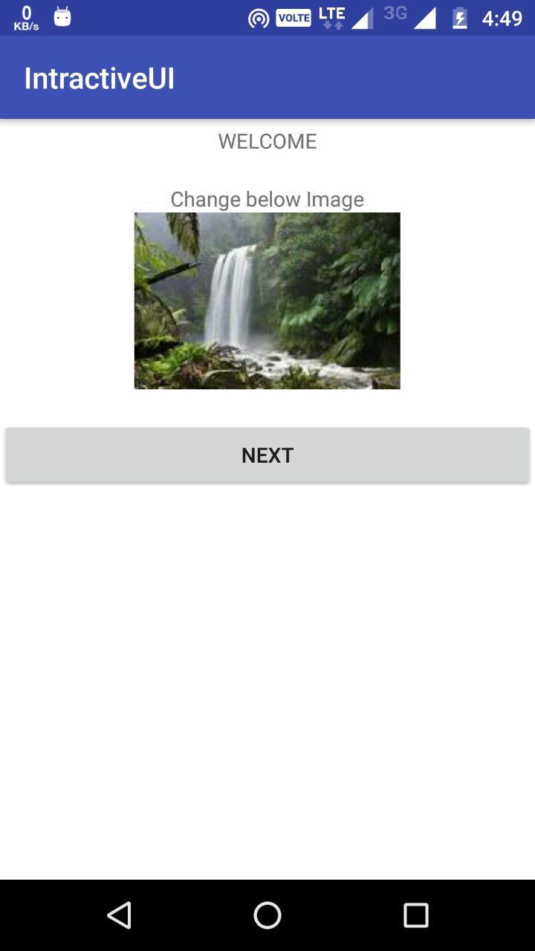

17

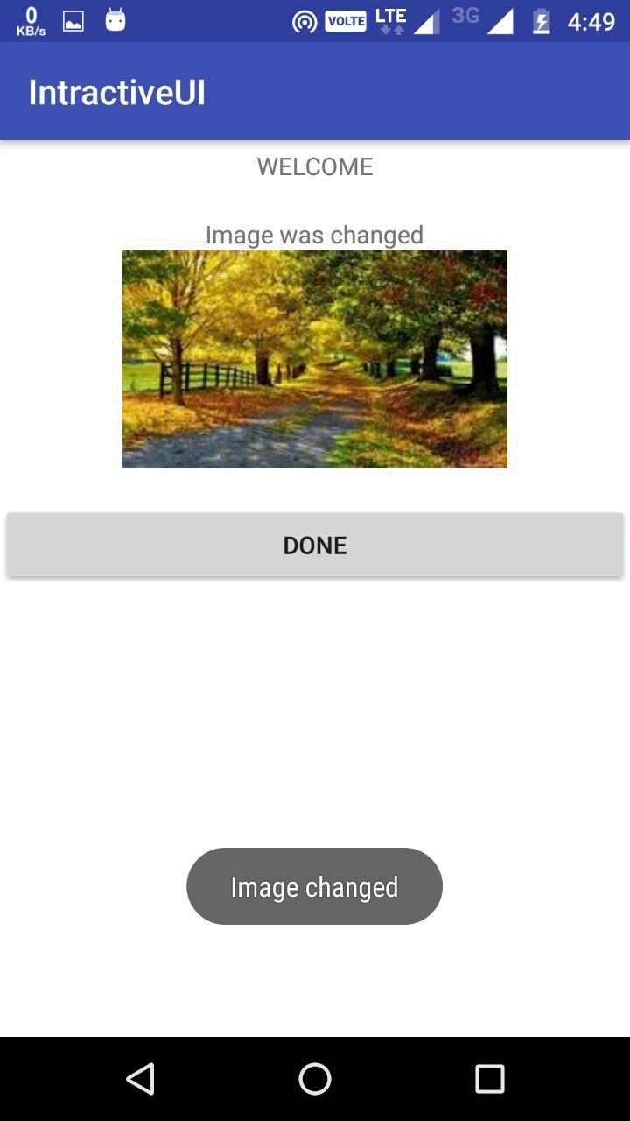

18

Practical:-2

AIM: Working with Text View Elements
- Use a scroll view for text with minor HTML formatting

AndroidManifest.xml

<?xml version="1.0" encoding="utf-8"?>

<manifest xmlns:android="http://schemas.android.com/apk/res/android" package="com.example.harsh.scrollview" >

<application

android:allowBackup="true"
android:icon="@mipmap/ic_launcher"

android:label="@string/app_name"
android:roundIcon="@mipmap/ic_launcher_round"
android:supportsRtl="true"
android:theme="@style/AppTheme" >

<activity android:name=".MainActivity"
android:exported="true">
<intent-filter>
<action android:name="android.intent.action.MAIN" />

<category android:name="android.intent.category.LAUNCHER" /> </intent-filter>

</activity>
</application>

</manifest>

MainActivity.java

package com.example.harsh.scrollview;

import android.os.Bundle;

import android.support.v7.app.AppCompatActivity; import android.text.Html; import android.text.Spanned;
import android.widget.TextView;

public class MainActivity extends AppCompatActivity { public static TextView t1,t2,t3,t4;

private final String htmlText = "<body><h1>Heading Text</h1><p>This tutorial " + "explains how to display " +

"<strong>HTML </strong>text in android text view.&nbsp;</p>" +
"<img src=\"hughjackman.jpg\">" +
"<blockquote>Practical of <a href=\"HTML FORMATTING\">" +
"stacktips.com<a></blockquote></body>";
@Override

19

protected void onCreate(Bundle savedInstanceState) { super.onCreate(savedInstanceState); setContentView(R.layout.activity_main);

t1 = (TextView) findViewById(R.id.t1);
t2 = (TextView) findViewById(R.id.t2);
t3 = (TextView) findViewById(R.id.t3);
t4 = (TextView) findViewById(R.id.t4);

String formattedText = "This <i>is</i> a <b>test</b> of <a href='http://foo.com'>html</a>";

- or getString(R.string.htmlFormattedText); t1.setText(fromHtml(formattedText));
  - t1.setText(Html.fromHtml("hello"));
//t2.setText(R.string.html);

t3.setText(fromHtml("<h2>Hello</h2><br/><br/><h4>Welcome</h4>"));
t2.setText(fromHtml("<h1>Main Title</h1>\n" +
- <h2>A sub-title</h2>\n" +
- <p>This is some html. Look, here\\'s an <u>underline</u>.</p>\n" +

- <p>Look, this is <em>emphasized.</em> And here\\'s some <b>bold</b>.</p>\n" +

- <p>This is a h4 tag text\n" +
- \n" +
- <h4>One\n" +
- Two\n" +
- Three</h4>\n" +
- \n" +
- <p>This is a h2 tag text:\n" +
- \n" +
- <h2>One\n" +
- Two\n" +
- Three</h2>\n" +
- "));

t4.setText(fromHtml(htmlText));
}
@SuppressWarnings("deprecation")

public static Spanned fromHtml(String html){ Spanned result;

if (android.os.Build.VERSION.SDK_INT >= android.os.Build.VERSION_CODES.N) { result = Html.fromHtml(html,Html.FROM_HTML_MODE_LEGACY);

} else {
result = Html.fromHtml(html);
}
return result;

}
}

20

activity_main.xml

<?xml version="1.0" encoding="utf-8"?>
<ScrollView xmlns:android="http://schemas.android.com/apk/res/android"

xmlns:tools="http://schemas.android.com/tools"
android:layout_width="match_parent"
android:layout_height="match_parent"
tools:context="com.example.harsh.scrollview.MainActivity"
>

<LinearLayout

android:layout_width="match_parent"
android:layout_height="match_parent"
android:orientation="vertical">

<TextView

android:layout_width="wrap_content"
android:layout_height="wrap_content"

android:id="@+id/t1"
/>

<TextView

android:layout_width="wrap_content"
android:layout_height="wrap_content"
android:id="@+id/t2"
/>

<TextView

android:layout_width="wrap_content"
android:layout_height="wrap_content"
android:id="@+id/t3"
/>

<TextView

android:layout_width="wrap_content"
android:layout_height="wrap_content"
android:id="@+id/t4"
/>

</LinearLayout>
</ScrollView>

21

Output:-

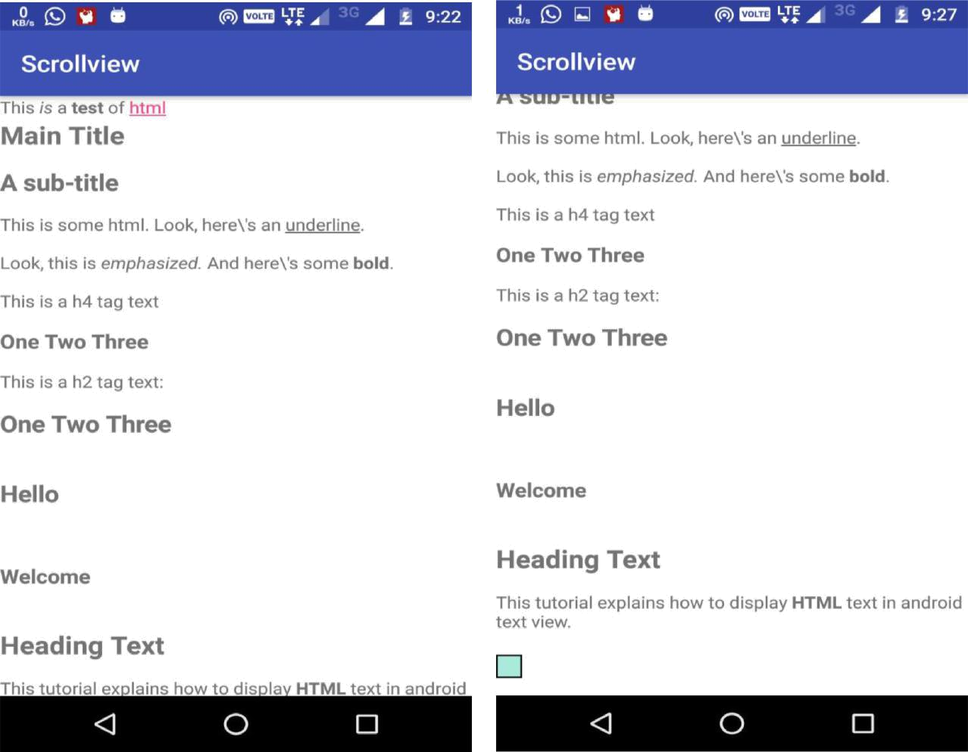

22

Practical:-3

AIM: Practical: Create and Start Activities.
- Create a new activity and layout.
- Start the new activity from an existing activity with an explicit intent.
- Pass user-entered information from one activity to the other.
- Pass information back to the main activity.

AndroidMenifest.xml

<?xml version="1.0" encoding="utf-8"?> <manifest

xmlns:android="http://schemas.android.com/apk/res/android" package="com.example.harsh.practical5">

<uses-sdk
android:minSdkVersion="8"

android:targetSdkVersion="25" />

<application

android:allowBackup="true"
android:icon="@mipmap/ic_launcher"
android:label="@string/app_name"
android:theme="@style/AppTheme" >

<activity

android:name=".MainActivity" android:label="@string/app_name" > <intent-filter>

<action
android:name="android.intent.action.MAIN" />

<category
android:name="android.intent.category.LAUNCHER" />
</intent-filter>
</activity>

<activity
android:name=".SecondActivity"

android:label="@string/title_activity_second" > </activity>
</application>

</manifest>

MainActivity.java
package com.example.harsh.practical5;

import android.os.Bundle;
import android.app.Activity;
import android.content.Intent;
import android.view.Menu;

import android.view.View;

23

import android.view.View.OnClickListener; import android.widget.Button; import android.widget.TextView;

public class MainActivity extends Activity { TextView textView1;

Button button1;

@Override

protected void onCreate(Bundle savedInstanceState) { super.onCreate(savedInstanceState); setContentView(R.layout.activity_main);

textView1=(TextView)findViewById(R.id.textView1); button1=(Button)findViewById(R.id.button1);

button1.setOnClickListener(new OnClickListener() {

@Override

public void onClick(View arg0) { Intent intent=new

Intent(MainActivity.this,SecondActivity.class); startActivityForResult(intent, 2);// Activity
is started with requestCode 2
}

});
}

- Call Back method to get the Message form other Activity @Override
protected void onActivityResult(int requestCode, int

resultCode, Intent data)

{

super.onActivityResult(requestCode, resultCode, data);

- check if the request code is same as what is passed here it is 2
if(requestCode==2)

{
String
message=data.getStringExtra("MESSAGE");

textView1.setText(message);

}

}

@Override

public boolean onCreateOptionsMenu(Menu menu) {

- Inflate the menu; this adds items to the action bar if it is present.
getMenuInflater().inflate(R.menu.main, menu);

24

return true;

}

}

SecondActivity.java
package com.example.harsh.practical5;

import android.os.Bundle;
import android.app.Activity;

import android.content.Intent;
import android.view.Menu;
import android.view.View;

import android.view.View.OnClickListener; import android.widget.Button; import android.widget.EditText;
import android.widget.TextView;

public class SecondActivity extends Activity { EditText editText1;
Button button1;

@Override

protected void onCreate(Bundle savedInstanceState) { super.onCreate(savedInstanceState); setContentView(R.layout.activity_second);

editText1=(EditText)findViewById(R.id.editText1); button1=(Button)findViewById(R.id.button1);

button1.setOnClickListener(new OnClickListener() {

@Override
public void onClick(View arg0) {

String message=editText1.getText().toString(); Intent intent=new Intent(); intent.putExtra("MESSAGE",message);

setResult(2,intent);

finish();//finishing activity
}
});

}

@Override

public boolean onCreateOptionsMenu(Menu menu) {

- Inflate the menu; this adds items to the action bar if it is present.

getMenuInflater().inflate(R.menu.second, menu); return true;
}

25

}

activity_main.xml
<RelativeLayout
xmlns:android="http://schemas.android.com/apk/res/android"

xmlns:tools="http://schemas.android.com/tools"
android:layout_width="match_parent"
android:layout_height="match_parent"

android:paddingBottom="@dimen/activity_vertical_margin"
android:paddingLeft="@dimen/activity_horizontal_margin"
android:paddingRight="@dimen/activity_horizontal_margin"
android:paddingTop="@dimen/activity_vertical_margin"

tools:context=".MainActivity" >

<TextView

android:id="@+id/textView1"
android:layout_width="wrap_content"
android:layout_height="wrap_content"
android:layout_alignLeft="@+id/button1"

android:layout_alignParentTop="true"
android:layout_marginTop="48dp"
android:text="Default Message" />

<Button
android:id="@+id/button1"
android:layout_width="wrap_content"

android:layout_height="wrap_content"
android:layout_below="@+id/textView1"
android:layout_centerHorizontal="true"

android:layout_marginTop="42dp"
android:text="GetMessage" />

</RelativeLayout>

activity_second.xml
<RelativeLayout
xmlns:android="http://schemas.android.com/apk/res/android"

xmlns:tools="http://schemas.android.com/tools"
android:layout_width="match_parent"
android:layout_height="match_parent"
android:paddingBottom="@dimen/activity_vertical_margin"

android:paddingLeft="@dimen/activity_horizontal_margin"
android:paddingRight="@dimen/activity_horizontal_margin"
android:paddingTop="@dimen/activity_vertical_margin"

tools:context=".SecondActivity" >

<EditText
android:id="@+id/editText1"

android:layout_width="wrap_content"
android:layout_height="wrap_content"

26

android:layout_alignParentTop="true"
android:layout_marginTop="61dp"

android:layout_toRightOf="@+id/textView1"
android:ems="10" />

<TextView

android:id="@+id/textView1"
android:layout_width="wrap_content"
android:layout_height="wrap_content"

android:layout_alignBaseline="@+id/editText1" android:layout_alignBottom="@+id/editText1" android:layout_alignParentLeft="true" android:text="Enter Message:" />

<Button
android:id="@+id/button1"
android:layout_width="wrap_content"

android:layout_height="wrap_content"
android:layout_below="@+id/editText1"
android:layout_centerHorizontal="true"
android:layout_marginTop="34dp"

android:text="Submit" />
</RelativeLayout>

27

Output:

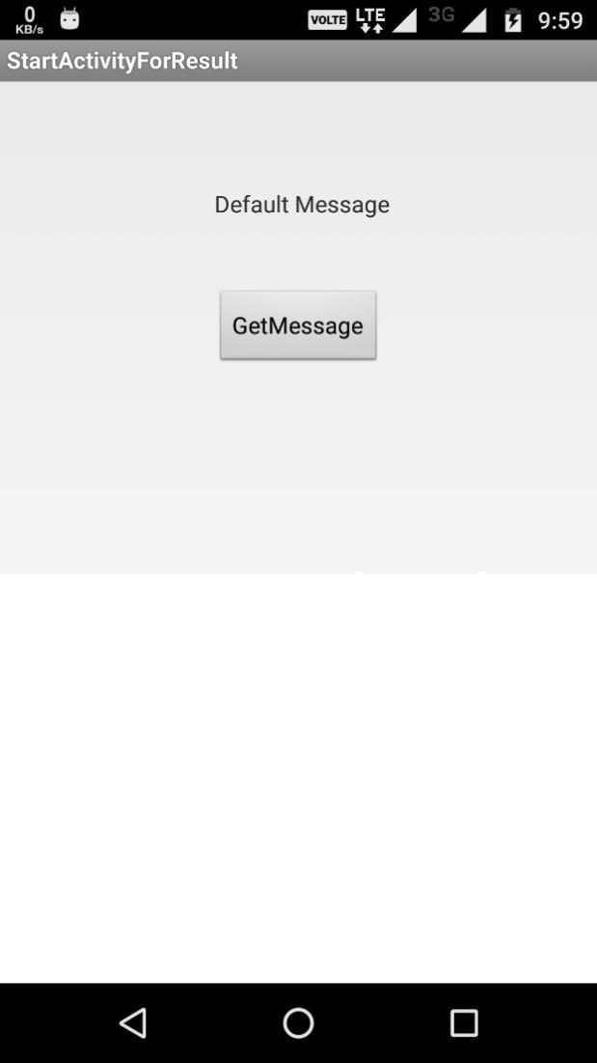

28


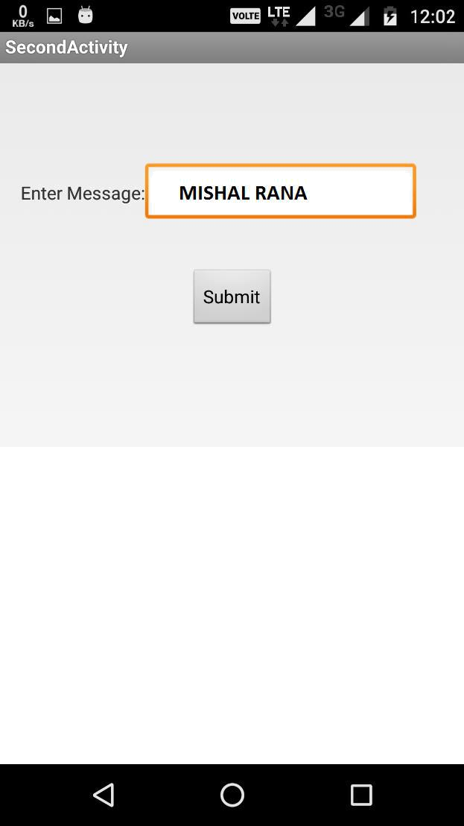

29


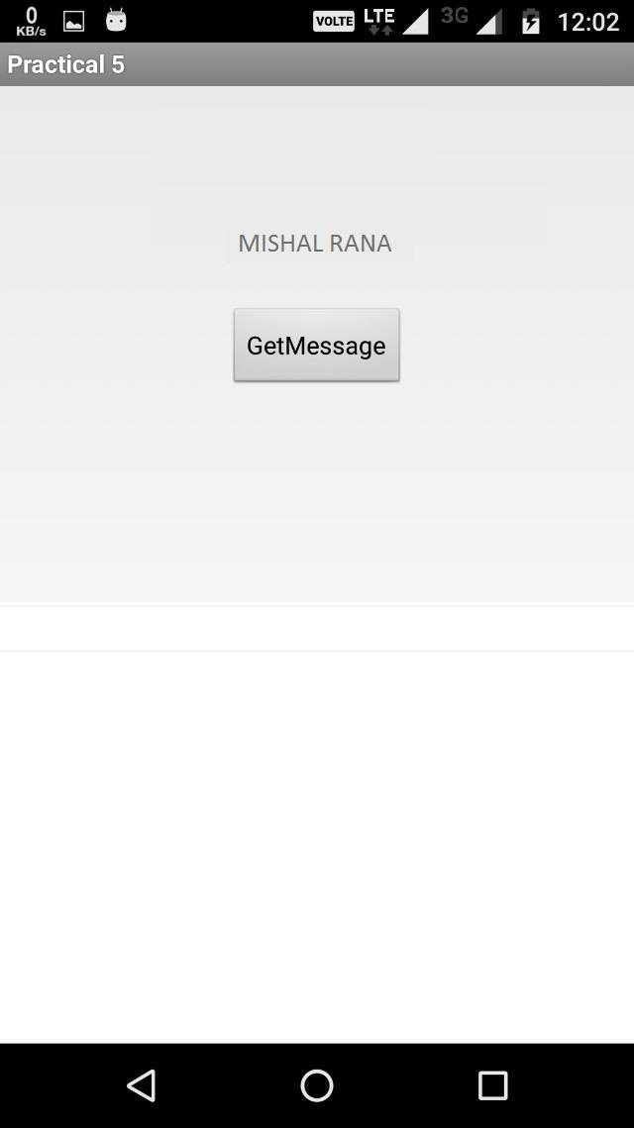

30

Practical:-4

AIM: Lifecycle and State Callbacks.
- Add Lifecycle callbacks.

- Save and restore instance state.

MainActivity.java
package com.example.harsh.practical6;

import android.app.Activity;
import android.os.Bundle;
import android.widget.Toast;

public class MainActivity extends Activity {

@Override

protected void onCreate(Bundle savedInstanceState) { super.onCreate(savedInstanceState); setContentView(R.layout.activity_main); Toast.makeText(this, "Oncreate Method Called",

Toast.LENGTH_LONG).show();

}

@Override

protected void onStart() {
super.onStart();
Toast.makeText(this, "Onstart Method Called",

Toast.LENGTH_LONG).show();

}

@Override

protected void onResume() {
super.onResume();
Toast.makeText(this, "Onresume Method Called",

Toast.LENGTH_LONG).show();

}

@Override

protected void onStop() {
super.onStop();

Toast.makeText(this, "Onstop Method Called", Toast.LENGTH_LONG).show();

}

@Override
protected void onRestart() {
super.onRestart();

31

Toast.makeText(this, "Onrestart Method Called",
Toast.LENGTH_LONG).show();

}

@Override
protected void onDestroy() {

super.onDestroy();
Toast.makeText(this, "Ondestroy Method Called",
Toast.LENGTH_LONG).show();

}

@Override
protected void onPause() {

super.onPause();
Toast.makeText(this, "Onpause Method Called",
Toast.LENGTH_LONG).show();

}
}

activity_main.xml
<?xml version="1.0" encoding="utf-8"?>
<android.support.constraint.ConstraintLayout
xmlns:android="http://schemas.android.com/apk/res/android"

xmlns:app="http://schemas.android.com/apk/res-auto"
xmlns:tools="http://schemas.android.com/tools"
android:layout_width="match_parent"

android:layout_height="match_parent"
tools:context="com.example.harsh.practical6.MainActivity">

<TextView

android:layout_width="wrap_content"
android:layout_height="wrap_content"
android:text="Hello World!"

app:layout_constraintBottom_toBottomOf="parent" app:layout_constraintLeft_toLeftOf="parent" app:layout_constraintRight_toRightOf="parent" app:layout_constraintTop_toTopOf="parent" />

</android.support.constraint.ConstraintLayout>

AndroidManifest.xml

<?xml version="1.0" encoding="utf-8"?> <manifest

xmlns:android="http://schemas.android.com/apk/res/android" package="com.example.harsh.practical6">

<application
android:allowBackup="true"

android:icon="@mipmap/ic_launcher"

32

android:label="@string/app_name"
android:supportsRtl="true"

android:theme="@style/AppTheme">
<activity android:name=".MainActivity">
<intent-filter>
<action

android:name="android.intent.action.MAIN" />

<category

android:name="android.intent.category.LAUNCHER" />
</intent-filter>
</activity>

</application>

</manifest>

33

Output:

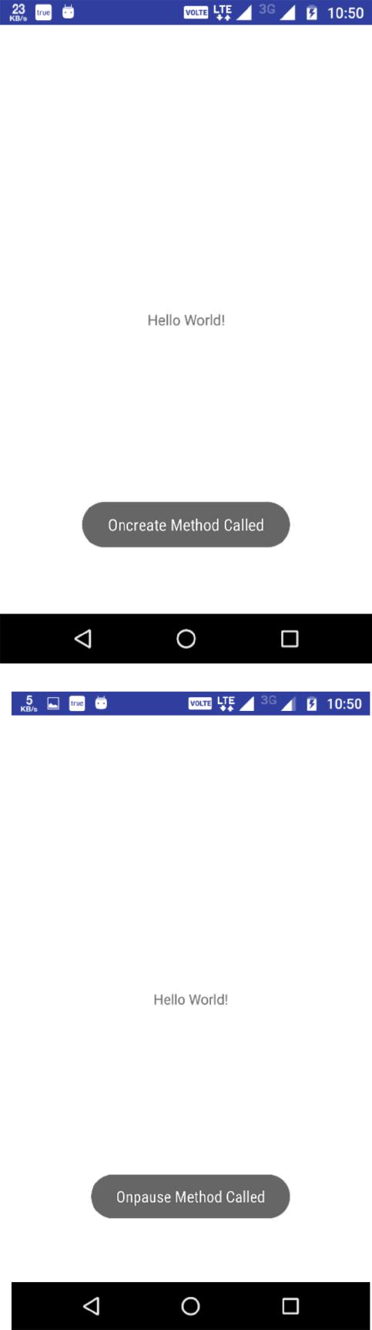

34


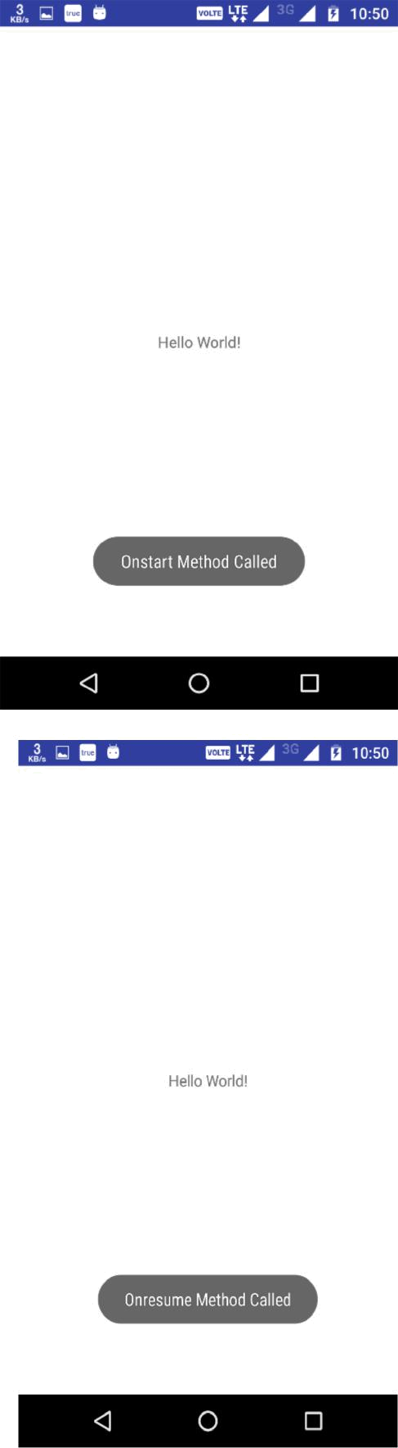

35


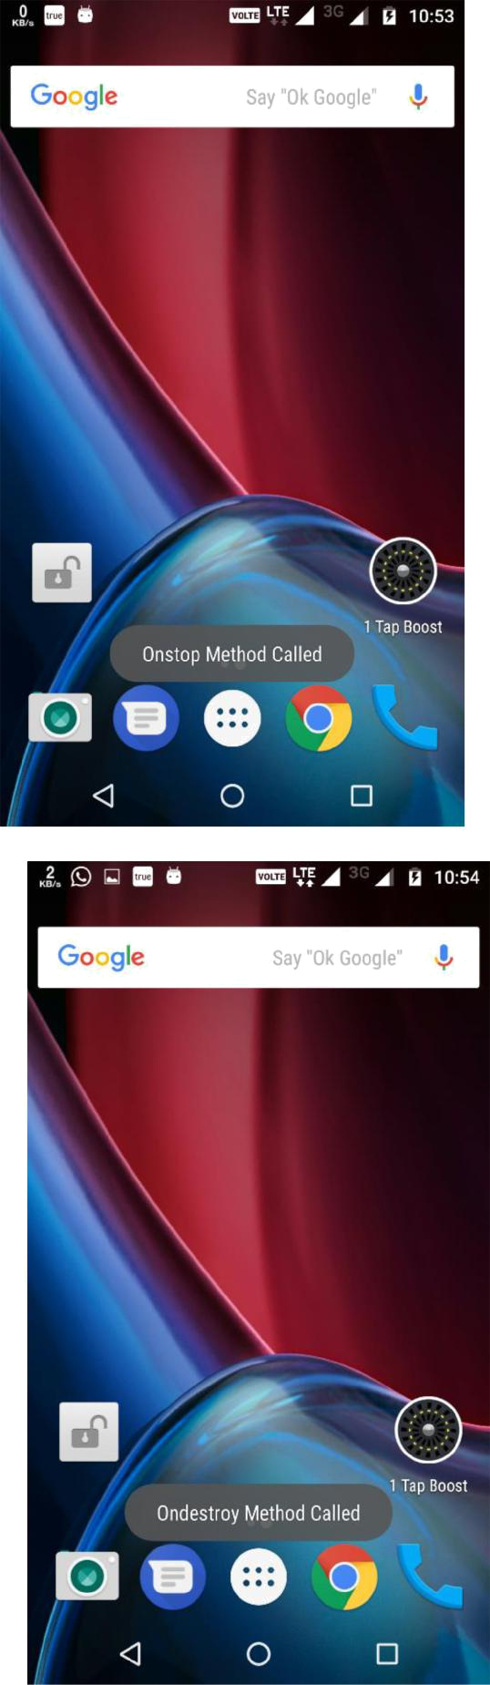

36

Practical:-5

AIM: Use Keyboards, Input Controls, Alerts, and Pickers

- Experiment in your app with different keyboards for user input, spelling suggestions, and auto-capitalization.

- Add a spinner input control for selecting one value out of a set of values.

- Create new app to show an alert, and record the user's selection (OK or Cancel). MOVE TO CONCEPT.

- Update app to show date and time pickers and record the user's selections.

AndroidManifest.xml

<?xml version="1.0" encoding="utf-8"?> <manifest

xmlns:android="http://schemas.android.com/apk/res/android" package="com.example.harsh.prac11">

<application

android:allowBackup="true"
android:icon="@mipmap/ic_launcher"
android:label="@string/app_name"

android:roundIcon="@mipmap/ic_launcher_round" android:supportsRtl="true" android:theme="@style/AppTheme">

<activity android:name=".MainActivity">

<intent-filter>
<action
android:name="android.intent.action.MAIN" />

<category
android:name="android.intent.category.LAUNCHER" />
</intent-filter>
</activity>

<activity android:name=".Result"></activity> </application>

</manifest>

MainActivity.java

package com.example.harsh.prac11;

import android.app.AlertDialog;

43

import android.app.DatePickerDialog; import android.app.TimePickerDialog; import android.content.DialogInterface; import android.content.Intent; import android.os.Bundle;

import android.support.v7.app.AppCompatActivity; import android.view.View;
import android.widget.AdapterView;
import android.widget.ArrayAdapter;

import android.widget.AutoCompleteTextView;

import android.widget.Button; import android.widget.CheckBox; import android.widget.DatePicker; import android.widget.EditText; import android.widget.RadioButton; import android.widget.RadioGroup; import android.widget.Spinner; import android.widget.TextView; import android.widget.TimePicker; import java.util.Calendar;

public class MainActivity extends AppCompatActivity { EditText fname,lname,birthdate,time;
TextView t1,t2;

AutoCompleteTextView city;
RadioGroup rg;
RadioButton male,female;

CheckBox c1,c2,c3;
Spinner sp;
Button b1;

Calendar c=Calendar.getInstance(); int month,year,day; int hour,min;

String[]
city11={"Ahmedabad","Amreli","Anand","Ankleshwar","Bharuch","B
havnagar","Bhuj","Cambay","Dahod","Deesa",

"Dholka","Gandhinagar","Godhra","Himatnagar","Idar","Jamnagar" ,"Junagadh","Kadi","Kalavad","Kalol",

"Kapadvanj","Karjan","Keshod","Khambhalia","Khambhat","Kheda", "Khedbrahma","Kheralu","Kodinar",

"Lathi","Limbdi","Lunawada","Mahesana","Mahuva","Manavadar","M andvi","Mangrol","Mansa","Mehmedabad","Modasa"

,"Morvi","Nadiad","Navsari","Padra","Palanpur","Palitana","Par di","Patan","Petlad","Porbandar",

"Radhanpur","Rajkot","Rajpipla","Rajula","Ranavav","Rapar","Sa

44

laya","Sanand","Savarkundla","Sidhpur","Sihor","Songadh",

"Surat","Talaja","Thangadh","Tharad","Umbergaon","Umreth","Una ","Unjha","Upleta","Vadnagar","Vadodara","Valsad",

"Vapi","Veraval","Vijapur","Viramgam","Visnagar","Vyara","Wadh wan","Wankaner"};

String fname1,lname1,gender1,ckb,items; @Override

protected void onCreate(Bundle savedInstanceState) { super.onCreate(savedInstanceState); setContentView(R.layout.activity_main);

fname=(EditText)findViewById(R.id.fname);

lname=(EditText)findViewById(R.id.lname);
birthdate=(EditText)findViewById(R.id.birthdate);
time=(EditText)findViewById(R.id.Tob);
t1=(TextView)findViewById(R.id.t1);

t2=(TextView)findViewById(R.id.t2);
city=(AutoCompleteTextView) findViewById(R.id.city);
rg=(RadioGroup)findViewById(R.id.rg);
male=(RadioButton)findViewById(R.id.male);

female=(RadioButton)findViewById(R.id.female);
c1=(CheckBox)findViewById(R.id.h1);
c2=(CheckBox)findViewById(R.id.h2);

c3=(CheckBox)findViewById(R.id.h3);
b1=(Button)findViewById(R.id.b1);
sp=(Spinner) findViewById(R.id.college_name);

final ArrayAdapter<String> adapter=new ArrayAdapter<String>(this,android.R.layout.select_dialog_item, city11);

city.setAdapter(adapter);
city.setThreshold(1);

birthdate.setOnClickListener(new View.OnClickListener() {

@Override
public void onClick(View v) {

year = c.get(Calendar.YEAR);
month = c.get(Calendar.MONTH);
day = c.get(Calendar.DAY_OF_MONTH);

DatePickerDialog dpd = new

DatePickerDialog(MainActivity.this, new DatePickerDialog.OnDateSetListener() {

@Override

public void onDateSet(DatePicker view, int year, int monthOfYear, int dayOfMonth) {

45

birthdate.setText((monthOfYear + 1) + "/" + dayOfMonth + "/" + year);

}
}, year, month, day);

dpd.show();

}
});

time.setOnClickListener(new View.OnClickListener() { @Override
public void onClick(View view) {
hour=c.get(Calendar.HOUR_OF_DAY);
min=c.get(Calendar.MINUTE);

TimePickerDialog td=new

TimePickerDialog(MainActivity.this, new TimePickerDialog.OnTimeSetListener() {

@Override
public void onTimeSet(TimePicker
timePicker, int hourOfDay, int minute) {
time.setText(hourOfDay + ":" +

minute);
}
},hour,min,false);

td.show();

}
});

String[] college={"Choose
College","GDEC","GEC","Nirma","MSU","GTU","Parul"};
final ArrayAdapter<String> college_name=new

ArrayAdapter<String>(this,android.R.layout.select_dialog_item, college);

adapter.setDropDownViewResource(android.R.layout.simple_spinne r_dropdown_item);
sp.setAdapter(college_name);

sp.setOnItemSelectedListener(new AdapterView.OnItemSelectedListener() {

@Override
public void onItemSelected(AdapterView<?> arg0,

View arg1,
int arg2, long arg3) {

items=sp.getSelectedItem().toString();

}

@Override
public void onNothingSelected(AdapterView<?> arg0)

{
- TODO Auto-generated method stub

46

}
});

b1.setOnClickListener(new View.OnClickListener() { @Override
public void onClick(View view) {

AlertDialog.Builder alertDialogBuilder = new AlertDialog.Builder(MainActivity.this);

alertDialogBuilder.setMessage("Are you sure, You wanted to Submit Data??");

alertDialogBuilder.setPositiveButton("yes", new DialogInterface.OnClickListener()

{

@Override
public void

onClick(DialogInterface arg0, int arg1) { fname1=fname.getText().toString(); lname1=lname.getText().toString();
if(male.isChecked())

{
gender1="MALE";

}

else

{
gender1="FEMALE";

}
if(c1.isChecked())

{

ckb=c1.getText().toString()+",";

}
if(c2.isChecked())

{

ckb=c2.getText().toString()+",";

}

if(c3.isChecked())

{

ckb=c3.getText().toString()+",";

}
Intent i=new
Intent(MainActivity.this,Result.class);

i.putExtra("fname",fname1);
i.putExtra("lname",lname1);

i.putExtra("city",city.getText().toString() );
i.putExtra("college",items);
i.putExtra("gender",gender1);
i.putExtra("hb",ckb);

47

i.putExtra("date",birthdate.getText().toString());

i.putExtra("time",time.getText().toString()); startActivity(i);

}

});
alertDialogBuilder.setNegativeButton("No",new

DialogInterface.OnClickListener() {

public void onClick(DialogInterface
dialog, int which) {

finish();
}
});

AlertDialog alertDialog =
alertDialogBuilder.create();
alertDialog.show();
}

});
}
}

Result.java

package com.example.harsh.prac11;

import android.os.Bundle;

import android.support.annotation.Nullable; import android.support.v7.app.AppCompatActivity; import android.widget.TextView;

public class Result extends AppCompatActivity {

TextView
fname,lname,city,college,gender,hobby,bod,tod,t1,t2,t3,t4,t5,t
6,t7,t8;

@Override

protected void onCreate(@Nullable Bundle savedInstanceState) {

super.onCreate(savedInstanceState); setContentView(R.layout.activity_result);

fname=(TextView)findViewById(R.id.fname); lname=(TextView)findViewById(R.id.lname); city=(TextView)findViewById(R.id.city); college=(TextView)findViewById(R.id.college); gender=(TextView)findViewById(R.id.gender); hobby=(TextView)findViewById(R.id.hb); bod=(TextView)findViewById(R.id.bd); tod=(TextView)findViewById(R.id.time);

t1=(TextView)findViewById(R.id.t1);
t2=(TextView)findViewById(R.id.t2);

48

t3=(TextView)findViewById(R.id.t3);
t4=(TextView)findViewById(R.id.t4);

t5=(TextView)findViewById(R.id.t5);
t6=(TextView)findViewById(R.id.t6);
t7=(TextView)findViewById(R.id.t7);
t8=(TextView)findViewById(R.id.t8);

Bundle b=getIntent().getExtras();

t1.setText(b.getString("fname".toString()).toUpperCase());

t2.setText(b.getString("lname".toString()).toUpperCase());
t3.setText(b.getString("city".toString()));

t4.setText(b.getString("college".toString()));
t5.setText(b.getString("gender".toString()));
t6.setText(b.getString("hb".toString()));

t7.setText(b.getString("date".toString()));
t8.setText(b.getString("time".toString()));

}

}

activity_main.xml
<?xml version="1.0" encoding="utf-8"?>
<LinearLayout

xmlns:android="http://schemas.android.com/apk/res/android"
xmlns:tools="http://schemas.android.com/tools"
android:id="@+id/activity_main"
android:layout_width="match_parent"

android:layout_height="wrap_content"
android:orientation="vertical"
tools:context="com.example.harsh.prac11.MainActivity">

<EditText
android:layout_width="match_parent"

android:layout_height="wrap_content"
android:id="@+id/fname"
android:hint="Enter First Name"

android:inputType="text" />
<EditText
android:layout_width="match_parent"
android:layout_height="wrap_content"

android:id="@+id/lname"
android:hint="Enter Last Name"
android:inputType="text" />

<AutoCompleteTextView
android:layout_width="match_parent"
android:layout_height="wrap_content"

android:id="@+id/city"

49

android:hint="Choose City"/>

<Spinner
android:layout_width="match_parent"
android:layout_height="wrap_content"
android:id="@+id/college_name">

</Spinner>
<TextView

android:layout_width="wrap_content" android:layout_height="wrap_content" android:id="@+id/t1" android:text="GENDER:"/>
<RadioGroup

android:layout_width="wrap_content"
android:layout_height="wrap_content"
android:orientation="horizontal"

android:paddingTop="10dp"
android:id="@+id/rg">
<RadioButton

android:layout_width="wrap_content" android:layout_height="wrap_content" android:id="@+id/male" android:text="MALE"/>
<RadioButton

android:layout_width="wrap_content"
android:layout_height="wrap_content"
android:id="@+id/female"

android:text="FEMALE"/>
</RadioGroup>
<TextView

android:layout_width="wrap_content" android:layout_height="wrap_content" android:id="@+id/t2" android:text="HOBBY:"/>
<CheckBox
android:layout_width="wrap_content"
android:layout_height="wrap_content"
android:id="@+id/h1"

android:text="SINGING"
android:paddingTop="10dp"/>
<CheckBox

android:layout_width="wrap_content"
android:layout_height="wrap_content"
android:id="@+id/h2"

android:text="DRAWING"/>

<CheckBox
android:layout_width="wrap_content"
android:layout_height="wrap_content"

android:id="@+id/h3"
android:text="DRIVING"/>
<EditText
android:layout_width="match_parent"

50

android:layout_height="wrap_content" android:id="@+id/birthdate" android:hint="Choose Birthdate"/>

<EditText
android:layout_width="match_parent"

android:layout_height="wrap_content"
android:id="@+id/Tob"
android:hint="Choose Time of Birth"/>

<Button
android:layout_width="wrap_content"
android:layout_height="wrap_content"

android:id="@+id/b1"
android:text="SUBMIT"/>

</LinearLayout>

activity_result.xml

<?xml version="1.0" encoding="utf-8"?>

<LinearLayout
xmlns:android="http://schemas.android.com/apk/res/android"

android:orientation="vertical" android:layout_width="match_parent" android:layout_height="match_parent" android:paddingTop="20dp"> <LinearLayout
android:layout_width="wrap_content"
android:layout_height="wrap_content"
android:orientation="horizontal"
>
<TextView
android:layout_width="wrap_content"
android:layout_height="wrap_content"
android:id="@+id/fname"

android:paddingTop="20dp"
android:text="First Name:"/>

<TextView
android:layout_width="wrap_content"
android:layout_height="wrap_content"
android:paddingTop="10dp"

android:id="@+id/t1"/>
</LinearLayout>
<LinearLayout

android:layout_width="wrap_content" android:layout_height="wrap_content" android:orientation="horizontal"> <TextView
android:layout_width="wrap_content"
android:layout_height="wrap_content"

51

android:id="@+id/lname"
android:paddingTop="10dp"

android:text="Last Name:"/>
<TextView
android:layout_width="wrap_content"
android:layout_height="wrap_content"

android:paddingTop="10dp"
android:id="@+id/t2"/>
</LinearLayout>

<LinearLayout

android:layout_width="wrap_content" android:layout_height="wrap_content" android:orientation="horizontal"> <TextView

android:layout_width="wrap_content" android:layout_height="wrap_content" android:paddingTop="10dp" android:id="@+id/city" android:text="city:"/>
<TextView

android:layout_width="wrap_content"
android:layout_height="wrap_content"
android:paddingTop="10dp"
android:id="@+id/t3"/>

</LinearLayout>
<LinearLayout

android:layout_width="wrap_content" android:layout_height="wrap_content" android:orientation="horizontal"> <TextView

android:layout_width="wrap_content" android:layout_height="wrap_content" android:id="@+id/college" android:paddingTop="10dp" android:text="College:"/>

<TextView
android:layout_width="wrap_content"
android:layout_height="wrap_content"

android:paddingTop="10dp"
android:id="@+id/t4"/>
</LinearLayout>

<LinearLayout

android:layout_width="wrap_content" android:layout_height="wrap_content" android:orientation="horizontal"> <TextView

android:layout_width="wrap_content" android:layout_height="wrap_content" android:id="@+id/gender" android:paddingTop="10dp" android:text="Gender:"/>
<TextView

52

android:layout_width="wrap_content" android:layout_height="wrap_content" android:paddingTop="10dp" android:id="@+id/t5"/>

</LinearLayout>
<LinearLayout

android:layout_width="wrap_content" android:layout_height="wrap_content" android:orientation="horizontal"> <TextView

android:layout_width="wrap_content" android:layout_height="wrap_content" android:paddingTop="10dp" android:id="@+id/hb" android:text="Hobby:"/>
<TextView

android:layout_width="wrap_content"
android:layout_height="wrap_content"
android:paddingTop="10dp"
android:id="@+id/t6"/>

</LinearLayout>
<LinearLayout

android:layout_width="wrap_content" android:layout_height="wrap_content" android:orientation="horizontal"> <TextView

android:layout_width="wrap_content" android:layout_height="wrap_content" android:paddingTop="10dp" android:id="@+id/bd" android:text="Birthdate:"/>

<TextView
android:layout_width="wrap_content"
android:layout_height="wrap_content"

android:paddingTop="10dp"
android:id="@+id/t7"/>
</LinearLayout>
<LinearLayout

android:layout_width="wrap_content" android:layout_height="wrap_content" android:orientation="horizontal"> <TextView
android:layout_width="wrap_content"
android:layout_height="wrap_content"
android:paddingTop="10dp"

android:id="@+id/time"
android:text="Time Of Birth:"/>
<TextView

android:layout_width="wrap_content"
android:layout_height="wrap_content"
android:paddingTop="10dp"
android:id="@+id/t8"/>

53

</LinearLayout>
</LinearLayout>

Output:

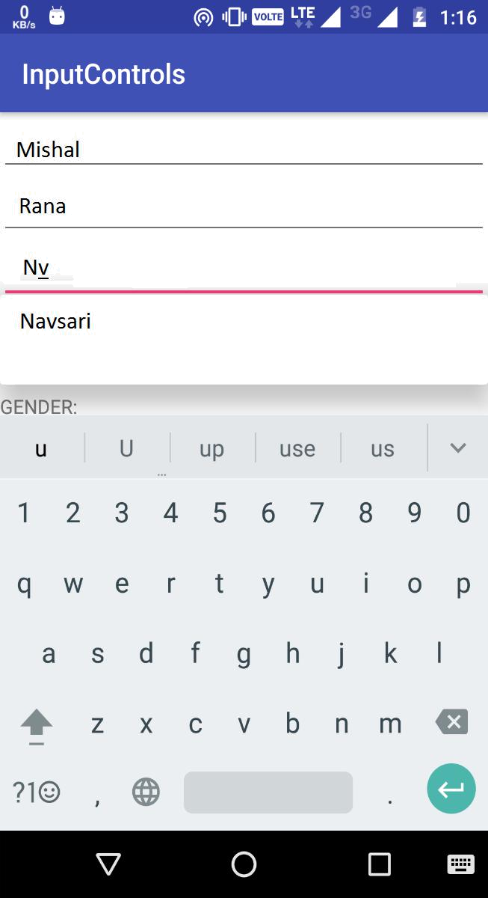

54


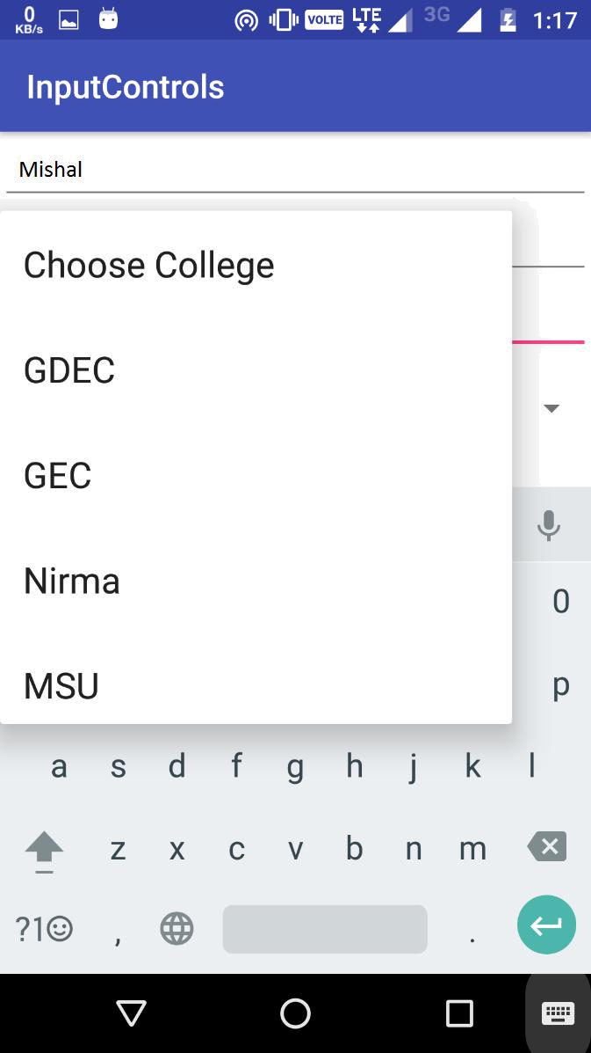

55


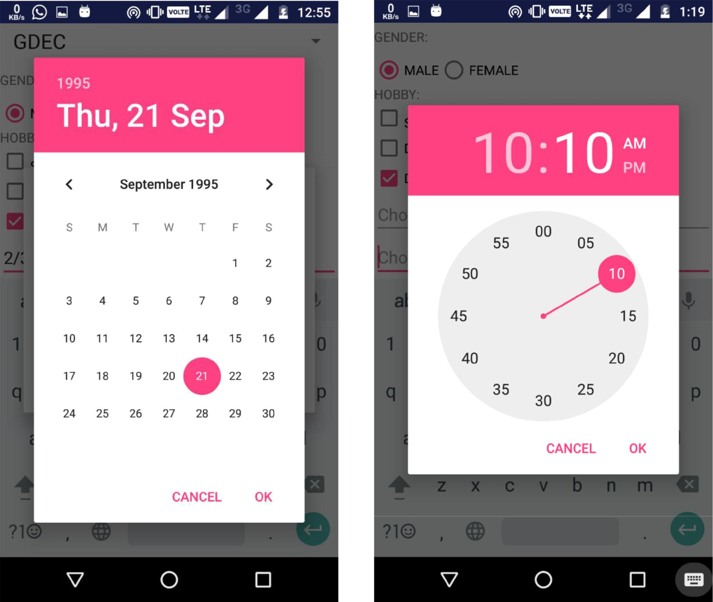

56


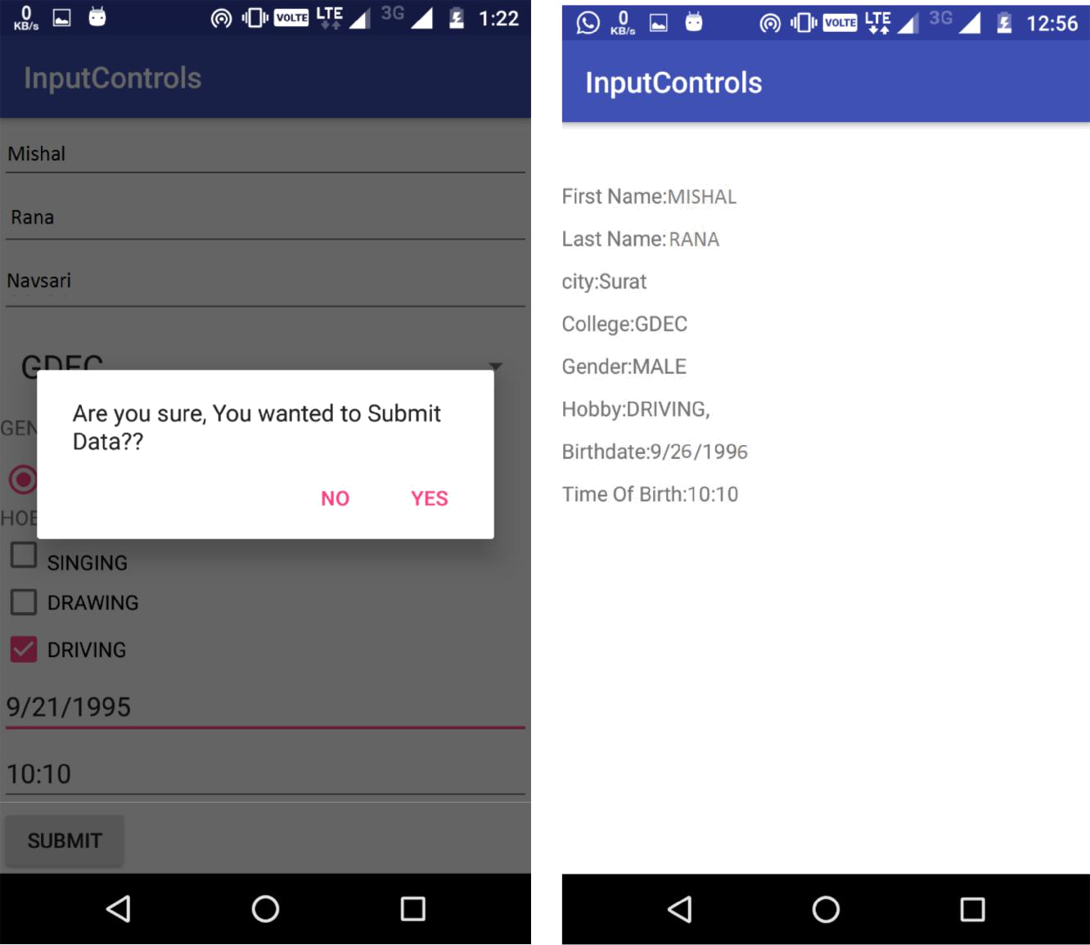

57

Practical:-06

AIM : Use an Options Menu and Radio Buttons.

- Set up an options menu and overflow menu
- Add items to the option (overflow) menu.
- Add radio buttons for user selection.
- Add Up navigation to the app bar.

AndroidManifest.xml

<?xml version="1.0" encoding="utf-8"?> <manifest

xmlns:android="http://schemas.android.com/apk/res/android" package="com.example.harsh.prac12">

<application

android:allowBackup="true"
android:icon="@mipmap/ic_launcher"
android:label="@string/app_name"

android:roundIcon="@mipmap/ic_launcher_round" android:supportsRtl="true" android:theme="@style/AppTheme">

<activity android:name=".MainActivity">

<intent-filter>
<action
android:name="android.intent.action.MAIN" />

<category
android:name="android.intent.category.LAUNCHER" />
</intent-filter>

</activity>
<activity android:name=".Help" />

<activity android:name=".About"></activity> </application>

</manifest>

MainActivity.java

package com.example.harsh.prac12;

import android.content.Intent;

import android.support.v7.app.AppCompatActivity; import android.os.Bundle; import android.view.Menu;

import android.view.MenuInflater; import android.view.MenuItem;

public class MainActivity extends AppCompatActivity {

58

@Override

public void onCreate(Bundle savedInstanceState) { super.onCreate(savedInstanceState); setContentView(R.layout.activity_main);

}

public boolean onCreateOptionsMenu(Menu menu) { MenuInflater inflater = getMenuInflater(); inflater.inflate(R.menu.menu, menu); return true;
}

public boolean onOptionsItemSelected(MenuItem item) { switch (item.getItemId()) {
case R.id.about:

Intent i=new
Intent(MainActivity.this,About.class);
startActivity(i);
return true;

case R.id.help:
Intent i1=new
Intent(MainActivity.this,Help.class);

startActivity(i1);

return true;
default:
return super.onOptionsItemSelected(item);

}
}
}

Help.java

package com.example.harsh.prac12;

import android.os.Bundle;
import android.support.annotation.Nullable;
import android.support.v7.app.ActionBar;
import android.support.v7.app.AppCompatActivity;

public class Help extends AppCompatActivity { @Override

protected void onCreate(@Nullable Bundle savedInstanceState) {

super.onCreate(savedInstanceState); setContentView(R.layout.activity_help); ActionBar actionBar = getSupportActionBar(); actionBar.setHomeButtonEnabled(true); actionBar.setDisplayHomeAsUpEnabled(true);
}
}

59

About.java

package com.example.harsh.prac12;

import android.os.Bundle;
import android.support.annotation.Nullable;

import android.support.v7.app.ActionBar;
import android.support.v7.app.AppCompatActivity;

public class About extends AppCompatActivity { @Override

protected void onCreate(@Nullable Bundle savedInstanceState) {

super.onCreate(savedInstanceState); setContentView(R.layout.activity_about);

ActionBar actionBar = getSupportActionBar(); actionBar.setHomeButtonEnabled(true); actionBar.setDisplayHomeAsUpEnabled(true);

}

}

activity_main.xml
<?xml version="1.0" encoding="utf-8"?>
<RelativeLayout

xmlns:android="http://schemas.android.com/apk/res/android"
xmlns:tools="http://schemas.android.com/tools"
android:id="@+id/activity_main"
android:layout_width="match_parent"

android:layout_height="match_parent"

tools:context="com.example.harsh.prac12.MainActivity">

<TextView
android:layout_width="wrap_content"
android:layout_height="wrap_content"

android:text="Hello World!" />
</RelativeLayout>

activity_help.xml

<?xml version="1.0" encoding="utf-8"?>
<RelativeLayout
xmlns:android="http://schemas.android.com/apk/res/android"

android:layout_width="match_parent" android:layout_height="match_parent" android:id="@+id/tv1">

<TextView
android:layout_width="wrap_content"
android:layout_height="wrap_content"

60

android:text="Help Page"
android:textStyle="bold"

android:textColor="@color/colorPrimary"
android:textSize="30sp"
android:layout_centerVertical="true"
android:layout_centerHorizontal="true" />

</RelativeLayout>

activity_about.xml

<?xml version="1.0" encoding="utf-8"?>
<RelativeLayout
xmlns:android="http://schemas.android.com/apk/res/android"

android:layout_width="match_parent" android:layout_height="match_parent">

<TextView
android:layout_width="wrap_content"
android:layout_height="wrap_content"
android:text="About Page"

android:textStyle="bold|italic"
android:id="@+id/tv1"
android:textColor="@color/colorPrimary"

android:textSize="30sp"
android:layout_centerVertical="true"
android:layout_centerHorizontal="true" />

</RelativeLayout>

menu.xml

<?xml version="1.0" encoding="utf-8"?> <menu

xmlns:android="http://schemas.android.com/apk/res/android">

<item android:id="@+id/about"
android:title="About" />

<item android:id="@+id/help"
android:title="Help" />
</menu>

61

Output

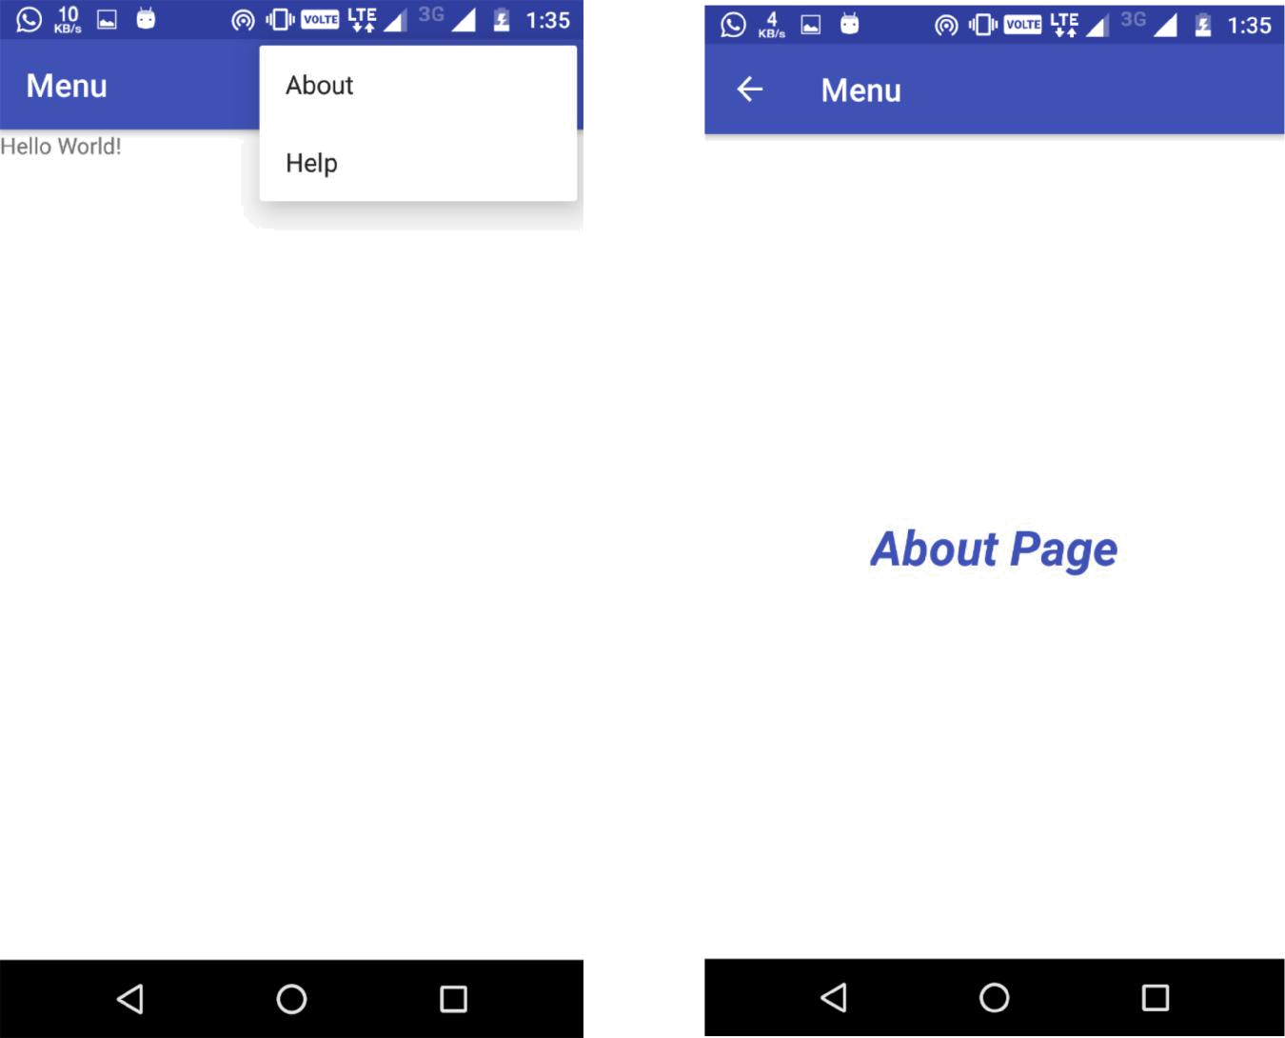

62


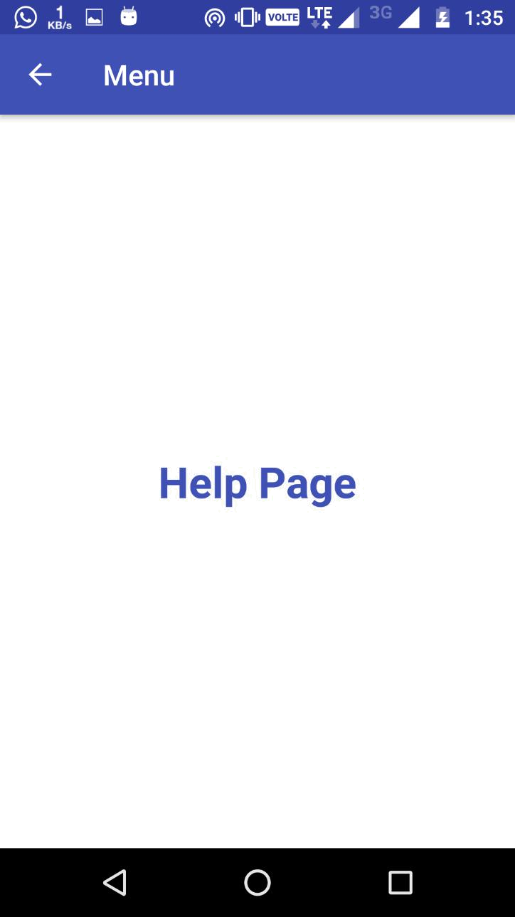

63

Practical:-7

AIM: Theme, Custom Styles, Drawables
- Define and use a theme
- Define and use a custom style that uses a drawable

ThemeActivity.java

public class ThemeActivity extends AppCompatActivity { private Spinner spThemes;

@Override

protected void onCreate(Bundle savedInstanceState) { super.onCreate(savedInstanceState); Utils.onActivityCreateSetTheme(this); setContentView(R.layout.activity_theme); setupSpinnerItemSelection();

}

private void setupSpinnerItemSelection() {

spThemes = (Spinner) findViewById(R.id.spThemes); spThemes.setSelection(ThemeApplication.currentPosition);

ThemeApplication.currentPosition = spThemes.getSelectedItemPosition();

spThemes.setOnItemSelectedListener(new AdapterView.OnItemSelectedListener() {

@Override

public void onItemSelected(AdapterView<?> parent, View view,

int position, long id) {

if (ThemeApplication.currentPosition !=
position) {

Utils.changeToTheme(ThemeActivity.this, position);

}

ThemeApplication.currentPosition =
position;

}

79

@Override

public void onNothingSelected(AdapterView<?>
parent) {

}

});

}

}

Utils.java
public class Utils {

private static int sTheme;

public final static int THEME_MATERIAL_LIGHT = 0; public final static int THEME_YOUR_CUSTOM_THEME = 1;

public static void changeToTheme(Activity activity, int theme) {

sTheme = theme;

activity.finish();

activity.startActivity(new Intent(activity, activity.getClass()));
activity.overridePendingTransition(android.R.anim.fade_in
,

android.R.anim.fade_out);

}

public static void onActivityCreateSetTheme(Activity activity) {

switch (sTheme) {

default:

case THEME_MATERIAL_LIGHT:

activity.setTheme(R.style.Theme_Material_Light); break;

case THEME_YOUR_CUSTOM_THEME:

activity.setTheme(R.style.Theme_YOUR_CUSTOM_THEME);

break;

}

80

}

}

activity_theme.xml
<RelativeLayout

xmlns:android="http://schemas.android.com/apk/res/android"

xmlns:tools="http://schemas.android.com/tools" android:layout_width="match_parent" android:layout_height="match_parent" > <TextView

android:id="@+id/tvSelectTheme" android:layout_width="wrap_content" android:layout_height="wrap_content" android:text="@string/settings_text_select_theme" />
<Spinner

android:id="@+id/spThemes" android:layout_width="wrap_content" android:layout_height="wrap_content" android:layout_alignBaseline="@+id/tvSelectTheme" android:layout_alignParentRight="true" android:layout_toRightOf="@+id/tvSelectTheme" android:entries="@array/theme_array" android:spinnerMode="dropdown" />
<RelativeLayout

android:id="@+id/rlCredentials" android:layout_width="wrap_content" android:layout_height="wrap_content" android:layout_below="@+id/tvSelectTheme" > <TextView

android:id="@+id/tvCredentials"

android:layout_width="wrap_content"

81

android:layout_height="wrap_content"

android:text="@string/settings_text_credentials"
/>

<EditText

android:id="@+id/tvUsername"

android:layout_width="match_parent"

android:layout_height="wrap_content"

android:layout_below="@+id/tvCredentials"

android:hint="@string/settings_text_username_hint"

android:inputType="text"

android:lines="1" />

<EditText

android:id="@+id/tvpassword" android:layout_width="match_parent" android:layout_height="wrap_content" android:layout_below="@+id/tvUsername" android:hint="@string/settings_text_password_hint" android:inputType="textPassword" android:lines="1" />

</RelativeLayout>

<TextView

android:id="@+id/tvSync"

android:layout_width="wrap_content"

android:layout_height="wrap_content"

android:layout_below="@+id/rlCredentials"

android:text="@string/settings_text_sync_automatically" android:textSize="17sp" />

<CheckBox

android:id="@+id/checkbox_sync_automatically"

android:layout_width="wrap_content"

82

android:layout_height="wrap_content" android:layout_alignBaseline="@+id/tvSync" android:layout_alignParentRight="true" android:checked="true" />
<TextView

android:id="@+id/tvLocation" android:layout_width="wrap_content" android:layout_height="wrap_content" android:layout_below="@+id/tvSync" android:text="@string/settings_text_location" android:textSize="17sp" />

<Switch

android:id="@+id/toggle_google"

android:layout_width="wrap_content"

android:layout_height="wrap_content"

android:layout_alignBaseline="@+id/tvLocation"

android:layout_alignParentRight="true"

android:layout_toRightOf="@+id/tvLocation"

android:textOff="@string/settings_text_state_off"

android:textOn="@string/settings_text_state_on" />

<Button

android:id="@+id/btnClearData" android:layout_width="wrap_content" android:layout_height="wrap_content" android:layout_alignParentBottom="true" android:layout_centerHorizontal="true" android:text="@string/settings_text_clear_data" />
</RelativeLayout>

attrs.xml
<?xml version="1.0" encoding="utf-8"?>

83

<resources>

<attr name="pageBackground" format="reference" /> <attr name="textSubheader" format="reference" /> <attr name="textLarge" format="reference" /> <attr name="textRegular" format="reference" /> <attr name="whiteBackground" format="reference" /> <attr name="button" format="reference" />

<attr name="spinner" format="reference" /> </resources>

dimens.xml
<resources>

<dimen name="activity_horizontal_padding">16dp</dimen> <dimen name="content_left_margin_wh">8sp</dimen> <dimen name="text_large_margin_top">40dp</dimen> <dimen name="text_large_text_size">18sp</dimen> <dimen name="text_subheader_text_size">16sp</dimen> <dimen name="text_regular_text_size">15sp</dimen> <dimen name="view_margin">20dp</dimen>

<dimen name="white_background_padding">20dp</dimen> <dimen name="edittext_margin_top">10dp</dimen> <dimen name="spinner_margin_left">10dp</dimen> <dimen name="card_margin_top">40dp</dimen>
</resources>

res/drawable/white_gray_gradient_background.xml
<?xml version="1.0" encoding="utf-8"?>

<shape
xmlns:android="http://schemas.android.com/apk/res/android" >

<gradient

android:angle="270"

android:endColor="#AFAFAF"

android:startColor="#FFFFFF" />

84

</shape>

button_wh_normal.xml

<?xml version="1.0" encoding="utf-8"?> <shape

xmlns:android="http://schemas.android.com/apk/res/android" android:shape="rectangle" >

<gradient

android:angle="270"

android:centerColor="#FFCECFCE" android:endColor="#FFBEBEBE" android:startColor="#FFF7F7F7" />
<padding

android:bottom="8dp"

android:left="16dp"

android:right="16dp"

android:top="8dp" />

<corners android:radius="48dp" /> </shape>

button_wh_pressed.xml

<?xml version="1.0" encoding="utf-8"?>

<shape
xmlns:android="http://schemas.android.com/apk/res/android"

android:shape="rectangle" >

<gradient

android:angle="270"

android:centerColor="#FF207FB9"

android:endColor="#FF0060B8"

android:startColor="#FF66CFE6" />

<padding

android:bottom="8dp"

85

android:left="8dp"

android:right="8dp"

android:top="8dp" />

<corners android:radius="48dp" />

</shape>

button_wh.xml

<?xml version="1.0" encoding="utf-8"?>

<selector
xmlns:android="http://schemas.android.com/apk/res/android">

<item android:drawable="@drawable/button_wh_pressed" android:state_pressed="true"/>

<item android:drawable="@drawable/button_wh_normal"/> </selector>

res/drawable/spinner_wh_background.xml

<?xml version="1.0" encoding="utf-8"?> <selector

xmlns:android="http://schemas.android.com/apk/res/android" android:opacity="transparent" >

<item android:state_pressed="true"> <shape android:shape="rectangle" >

<solid android:color="#00000000" /> </shape>

</item>

<item android:state_selected="true"> <shape android:shape="rectangle" >

<solid android:color="#00000000" /> </shape>

</item>

<item
android:drawable="@drawable/spinner_default_holo_light">

</item>

86

</selector>

styles.xml

<resources>

<style name="AppBaseTheme" parent="Theme.AppCompat.Light">

</style>

<style name="AppTheme" parent="AppBaseTheme">

</style>

<style name="switch_text_appearance" parent="@android:style/TextAppearance.Holo.Small">

<item name="android:textColor">#FFF</item>

</style>

<style name="page_background_wh">

<item
name="android:background">@drawable/white_gray_gradient_backgr
ound</item>

<item
name="android:paddingLeft">@dimen/activity_horizontal_padding<
/item>

<item
name="android:paddingRight">@dimen/activity_horizontal_padding
</item>

</style>

<style name="text_subheader_wh">

<item name="android:textColor">#000</item>

<item
name="android:textSize">@dimen/text_subheader_text_size</item>

<item name="android:shadowDy">1.0</item>

<item name="android:shadowRadius">1</item>

<item name="android:shadowColor">#000</item>

</style>

<style name="text_large_wh">

<item
name="android:textColor">@android:color/background_dark</item>

87

<item
name="android:textSize">@dimen/text_large_text_size</item>

<item name="android:shadowDy">1.0</item> <item name="android:shadowRadius">1</item> <item name="android:shadowColor">#888</item> <item name="android:textStyle">bold</item> <item
name="android:layout_marginTop">@dimen/text_large_margin_top</
item>

</style>

<style name="text_regular_wh">

<item
name="android:textColor">@android:color/background_dark</item>

<item
name="android:textSize">@dimen/text_regular_text_size</item>

</style>

<style name="white_background_wh">

<item
name="android:background">@android:drawable/dialog_holo_light_
frame</item>

<item
name="android:layout_marginTop">@dimen/card_margin_top</item>

<item
name="android:layout_marginBottom">@dimen/card_margin_top</ite
m>

<item
name="android:padding">@dimen/white_background_padding</item>

</style>

<style name="button_wh" parent="text_large_wh">

<item
name="android:background">@drawable/button_wh</item>

<item
name="android:layout_marginTop">@dimen/view_margin</item>

</style>

<style name="spinner_wh">

88

<item
name="android:background">@drawable/spinner_wh_background</ite

m>

</style>

<style name="horizontal_line_wh">

<item name="android:background">#00000000</item>

</style>

<color name="actionbar_bg_wh">#AFAFAF</color>

<style name="action_bar_wh"

parent="@style/Widget.AppCompat.Light.ActionBar.Solid.Inverse"
>

<item

name="android:background">@color/actionbar_bg_wh</item>

<item name="background">@color/actionbar_bg_wh</item>

</style>

</resources>

res/values/ themes.xml

<?xml version="1.0" encoding="utf-8"?>

<resources

xmlns:android="http://schemas.android.com/apk/res/android">

<style name="Theme.Material_Light"
parent="Theme.AppCompat.Light">

<item
name="pageBackground">@style/page_background_wh</item>

<item
name="textSubheader">@style/text_subheader_wh</item>

<item name="textLarge">@style/text_large_wh</item> <item name="textRegular">@style/text_regular_wh</item> <item

name="whiteBackground">@style/white_background_wh</item>

<item name="button">@style/button_wh</item> <item name="spinner">@style/spinner_wh</item> <item
name="actionBarStyle">@style/action_bar_wh</item>

89

</style>

<style name="Theme.YOUR_CUSTOM_THEME"

parent="Theme.AppCompat.Light">

</style>

</resources>

strings.xml

<?xml version="1.0" encoding="utf-8"?> <resources>

<string name="app_name">Theme Switcher</string>

<string name="settings_text_select_theme">Select Theme:</string>

<string
name="settings_text_credentials">Credentials</string>

<string
name="settings_text_username_hint">username</string>

<string
name="settings_text_password_hint">password</string>

<string name="settings_text_sync_automatically">Sync automatically</string>

<string name="settings_text_location">Location</string> <string name="settings_text_state_on">On</string> <string name="settings_text_state_off">Off</string>

<string name="settings_text_clear_data">Clear Data</string>

</resources>

90

Output:

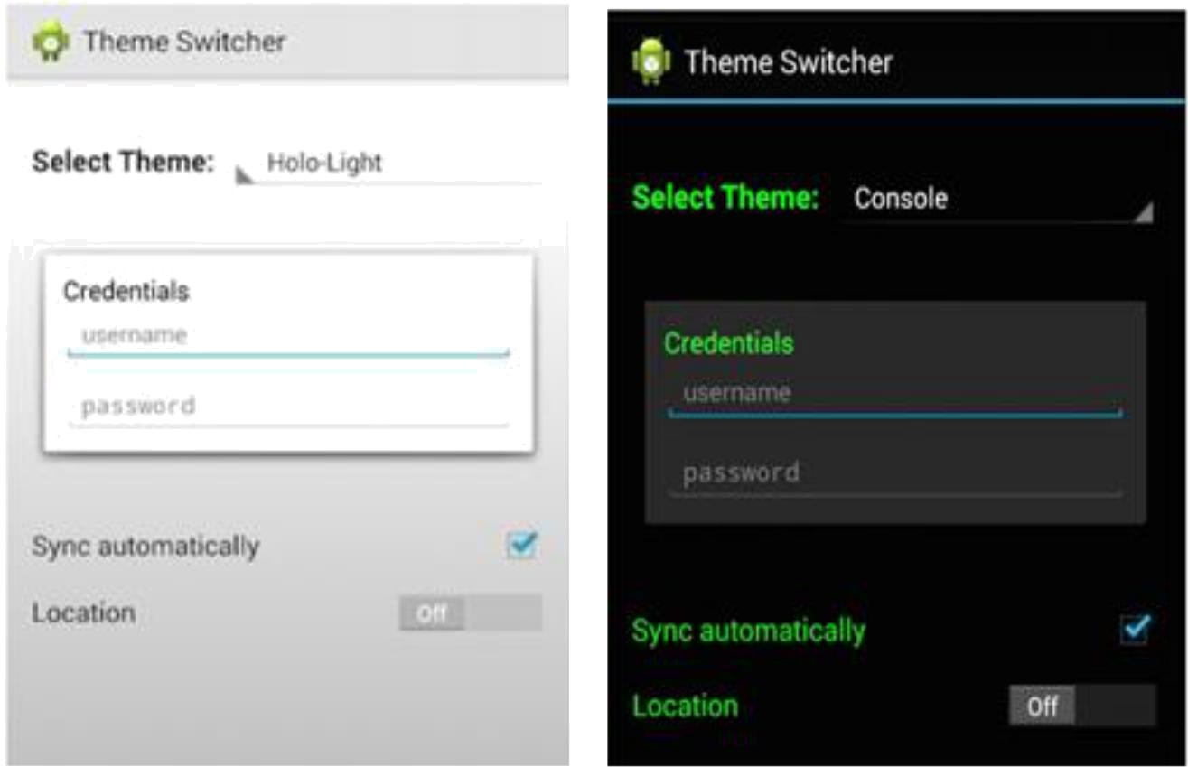

91

Practical:-8

AIM: Create an AsyncTask
- Create a simple AsyncTask to do work in the background.

AndroidManifest.xml

<?xml version="1.0" encoding="utf-8"?> <manifest

xmlns:android="http://schemas.android.com/apk/res/android" package="com.example.harsh.loader">

<application
android:allowBackup="true"
android:icon="@mipmap/ic_launcher"

android:label="@string/app_name"

android:roundIcon="@mipmap/ic_launcher_round" android:supportsRtl="true" android:theme="@style/AppTheme">

<activity android:name=".MainActivity">
<intent-filter>
<action
android:name="android.intent.action.MAIN" />

<category
android:name="android.intent.category.LAUNCHER" />

</intent-filter>
</activity>
</application>

</manifest>

MainActivity.java

package com.example.harsh.loader;

import android.app.ProgressDialog; import android.os.AsyncTask; import android.os.Bundle;

import android.support.v7.app.AppCompatActivity; import android.view.View; import android.widget.Button;

import android.widget.EditText;
import android.widget.TextView;

public class MainActivity extends AppCompatActivity { private Button button;
private EditText time;

private TextView finalResult;

@Override
protected void onCreate(Bundle savedInstanceState) {

92

super.onCreate(savedInstanceState);
setContentView(R.layout.activity_main);

time = (EditText) findViewById(R.id.in_time);
button = (Button) findViewById(R.id.btn_run);
finalResult = (TextView) findViewById(R.id.tv_result);
button.setOnClickListener(new View.OnClickListener() {

@Override

public void onClick(View v) { AsyncTaskRunner runner = new

AsyncTaskRunner();

String sleepTime = time.getText().toString(); runner.execute(sleepTime);
}

});
}

private class AsyncTaskRunner extends AsyncTask<String, String, String> {

private String resp;

ProgressDialog progressDialog;

@Override

protected String doInBackground(String... params) { publishProgress("Sleeping..."); // Calls

onProgressUpdate()
try {

int time = Integer.parseInt(params[0])*1000;

Thread.sleep(time);
resp = "Slept for " + params[0] + " seconds";

} catch (InterruptedException e) { e.printStackTrace();

resp = e.getMessage(); } catch (Exception e) {

e.printStackTrace(); resp = e.getMessage();

}

return resp;

}

@Override
protected void onPostExecute(String result) {

// execution of result of Long time consuming

operation
progressDialog.dismiss();
finalResult.setText(result);

}

@Override

93

protected void onPreExecute() {
progressDialog =

ProgressDialog.show(MainActivity.this, "ProgressDialog",
"Wait for "+time.getText().toString()+ "
seconds");

}

@Override

protected void onProgressUpdate(String... text) { finalResult.setText(text[0]);

}
}
}

activity_main.xml

<?xml version="1.0" encoding="utf-8"?>
<RelativeLayout

xmlns:android="http://schemas.android.com/apk/res/android"

xmlns:tools="http://schemas.android.com/tools" android:layout_width="match_parent" android:layout_height="match_parent" tools:context=".MainActivity" >

<TextView

android:id="@+id/tv_time"
android:layout_width="wrap_content"
android:layout_height="wrap_content"

android:textSize="10pt"

android:textColor="#444444"
android:layout_alignParentLeft="true"
android:layout_marginRight="9dip"

android:layout_marginTop="20dip"
android:layout_marginLeft="10dip"
android:text="Sleep time in Seconds:"/>
<EditText

android:id="@+id/in_time"
android:layout_width="150dip"
android:layout_height="wrap_content"

android:background="@android:drawable/editbox_background"
android:layout_toRightOf="@id/tv_time"
android:layout_alignTop="@id/tv_time"

android:inputType="number"

/>
<Button

android:id="@+id/btn_run"
android:layout_width="wrap_content"
android:layout_height="wrap_content"

94

android:text="Run Async task" android:layout_below="@+id/in_time" android:layout_centerHorizontal="true" android:layout_marginTop="64dp" />
<TextView
android:id="@+id/tv_result"

android:layout_width="wrap_content"
android:layout_height="wrap_content"
android:textSize="7pt"

android:layout_below="@+id/btn_run"

android:layout_centerHorizontal="true"
</RelativeLayout>

95

/>

Output:-

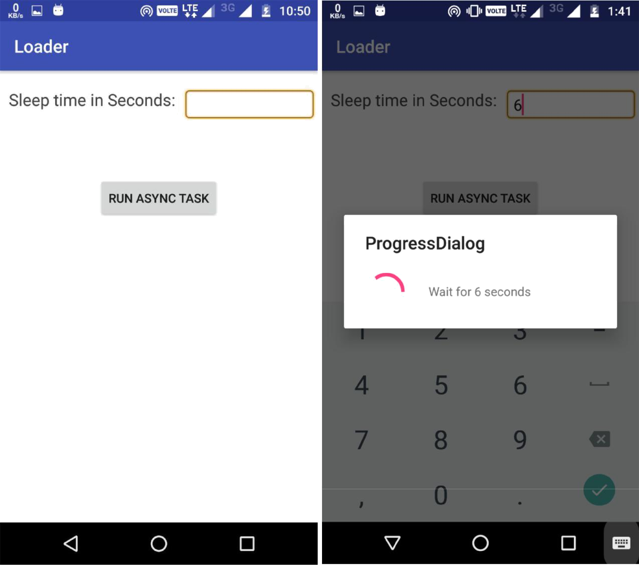

96

Practical:-9

AIM: Practical: Use AsyncTaskLoader.

- Use AsyncTaskLoader instead of AsyncTask to show book search results in a RecyclerView.

MainActivity.java
package com.example.harsh.practical21;

import android.support.v7.app.AppCompatActivity; import android.os.Bundle;

import java.util.ArrayList;
import java.util.List;

import android.os.Bundle;

import android.support.v4.app.FragmentActivity; import android.support.v4.app.LoaderManager; import android.support.v4.content.Loader; import android.widget.ListView;

public class MainActivity extends FragmentActivity implements LoaderManager.LoaderCallbacks<List<Employee>> {

EmployeeAdapter empAdapter;

@Override

public void onCreate(Bundle savedInstanceState) { super.onCreate(savedInstanceState); setContentView(R.layout.main);

empAdapter = new EmployeeAdapter(this, new

ArrayList<Employee>());

ListView employeeListView = (ListView)
findViewById(R.id.employees);

employeeListView.setAdapter(empAdapter); getSupportLoaderManager().initLoader(1, null,
this).forceLoad();

}
@Override

public Loader<List<Employee>> onCreateLoader(int id, Bundle args) {
return new EmployeeLoader(MainActivity.this);

}
@Override

public void onLoadFinished(Loader<List<Employee>> loader, List<Employee> data) {

empAdapter.setEmployees(data);

}
@Override

public void onLoaderReset(Loader<List<Employee>> loader) { empAdapter.setEmployees(new ArrayList<Employee>());

}
}

Employee.java

97

package com.example.harsh.practical21;

/**
- Created by Harsh on 4/3/2017.
*/

public class Employee {
public String empid;
public String name;

public Employee(String id, String name) { this.empid = id;
this.name = name;
}

}

EmployeeLoader.java
package com.example.harsh.practical21;

import java.util.ArrayList;
import java.util.List;
import android.content.Context;

import android.support.v4.content.AsyncTaskLoader; public class EmployeeLoader extends AsyncTaskLoader<List<Employee>> {

public EmployeeLoader(Context context) { super(context);

}
@Override

public List<Employee> loadInBackground() { List<Employee> list = new ArrayList<Employee>(); list.add(new Employee("emp1", "Brahma")); list.add(new Employee("emp2", "Vishnu")); list.add(new Employee("emp3", "Mahesh")); return list;

}
}

employeedata.xml
<?xml version="1.0" encoding="utf-8"?>
<LinearLayout

xmlns:android="http://schemas.android.com/apk/res/android"

android:layout_width="match_parent" android:layout_height="match_parent" android:orientation="horizontal" android:background="#D1C4E9"> <TextView
android:id="@+id/empid"

android:textSize="25sp"
android:layout_width="wrap_content"
android:layout_height="wrap_content"
android:textColor="#FF8A80"

98

android:layout_weight="2"/>
<TextView

android:id="@+id/empname"
android:textSize="25sp"
android:layout_width="wrap_content"
android:layout_height="wrap_content"

android:textColor="#FF8A80"
android:layout_weight="2"/>
</LinearLayout>

Main.xml
<?xml version="1.0" encoding="utf-8"?>
<LinearLayout
xmlns:android="http://schemas.android.com/apk/res/android"

android:orientation="vertical" android:layout_width="fill_parent" android:layout_height="fill_parent" android:background="#C98C00"> <ListView
android:id="@+id/employees"

android:layout_height="match_parent" android:layout_width="match_parent"/>

</LinearLayout>

AndroidManifest.xml

<?xml version="1.0" encoding="utf-8"?> <manifest

xmlns:android="http://schemas.android.com/apk/res/android" package="com.example.harsh.practical21">

<application
android:allowBackup="true"
android:icon="@mipmap/ic_launcher"
android:label="@string/app_name"

android:supportsRtl="true"
android:theme="@style/AppTheme">

<activity android:name=".MainActivity" android:theme="@android:style/Theme.NoTitleBar">
<intent-filter>
<action
android:name="android.intent.action.MAIN" />

<category
android:name="android.intent.category.LAUNCHER" />
</intent-filter>

</activity>
</application>

</manifest>

99

Output:-

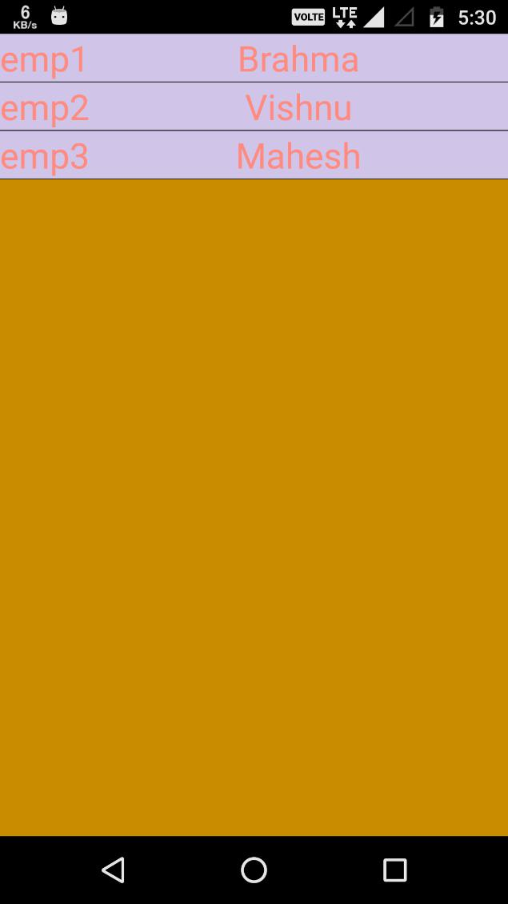

100

Practical:-10

AIM: Create an app with a Broadcast Receiver.

MainActivity.java
package com.example.harsh.practical22;

import android.content.Intent;
import android.graphics.Color;
import android.os.Bundle;

import android.support.design.widget.FloatingActionButton; import android.support.design.widget.Snackbar;

import android.support.v7.app.AppCompatActivity; import android.support.v7.widget.Toolbar; import android.view.View; import android.widget.Button;

import android.widget.TextView;

public class MainActivity extends AppCompatActivity implements

ConnectivityReceiver.ConnectivityReceiverListener {

private FloatingActionButton fab; private Button btnCheck;

@Override

protected void onCreate(Bundle savedInstanceState) { super.onCreate(savedInstanceState); setContentView(R.layout.activity_main); Toolbar toolbar = (Toolbar)

findViewById(R.id.toolbar);

setSupportActionBar(toolbar);

btnCheck = (Button) findViewById(R.id.btn_check); fab = (FloatingActionButton) findViewById(R.id.fab);

- Manually checking internet connection checkConnection();

btnCheck.setOnClickListener(new View.OnClickListener()

{
@Override
public void onClick(View v) {

- Manually checking internet connection checkConnection();

}
});

fab.setOnClickListener(new View.OnClickListener() { @Override

101

public void onClick(View v) {
startActivity(new Intent(MainActivity.this,

SecondActivity.class));

}
});
}

private void checkConnection() { boolean isConnected =

ConnectivityReceiver.isConnected(); showSnack(isConnected);
}

private void showSnack(boolean isConnected) { String message;
int color;

if (isConnected) {

message = "Good! Connected to Internet"; color = Color.WHITE;
} else {

message = "Sorry! Not connected to internet"; color = Color.RED;

}

Snackbar snackbar = Snackbar

.make(findViewById(R.id.fab), message, Snackbar.LENGTH_LONG);

View sbView = snackbar.getView(); TextView textView = (TextView)

sbView.findViewById(android.support.design.R.id.snackbar_text) ;

textView.setTextColor(color);
snackbar.show();

}

@Override
protected void onResume() {

super.onResume();

// register connection status listener

MyApplication.getInstance().setConnectivityListener(this);

}

/**
- Callback will be triggered when there is change in
- network connection

*/
@Override

public void onNetworkConnectionChanged(boolean isConnected) {

102

showSnack(isConnected);
}

}

SecondActivity.java
package com.example.harsh.practical22;

import android.graphics.Color;
import android.os.Bundle;

import android.support.design.widget.Snackbar; import android.support.v7.app.AppCompatActivity; import android.support.v7.widget.Toolbar; import android.view.View; import android.widget.TextView;

public class SecondActivity extends AppCompatActivity implements

ConnectivityReceiver.ConnectivityReceiverListener {

@Override

protected void onCreate(Bundle savedInstanceState) { super.onCreate(savedInstanceState); setContentView(R.layout.activity_second); Toolbar toolbar = (Toolbar)

findViewById(R.id.toolbar);

setSupportActionBar(toolbar);
getSupportActionBar().setDisplayHomeAsUpEnabled(true);

}

@Override
protected void onResume() {
super.onResume();

// register connection status listener

MyApplication.getInstance().setConnectivityListener(this);

}

@Override

public void onNetworkConnectionChanged(boolean isConnected) {

showSnack(isConnected);

}

private void showSnack(boolean isConnected) { String message;

int color;
if (isConnected) {

message = "Good! Connected to Internet"; color = Color.WHITE;
} else {

103

message = "Sorry! Not connected to internet"; color = Color.RED;

}

Snackbar snackbar = Snackbar

.make(findViewById(R.id.coordinator_layout), message, Snackbar.LENGTH_LONG);

View sbView = snackbar.getView(); TextView textView = (TextView)

sbView.findViewById(android.support.design.R.id.snackbar_text) ;

textView.setTextColor(color);

snackbar.show();
}
}

Myapplication.java
package com.example.harsh.practical22;

import android.app.Application;

/**
- Created by Ravi Tamada on 15/06/16.
- www.androidhive.info

*/
public class MyApplication extends Application {

private static MyApplication mInstance;

@Override
public void onCreate() {

super.onCreate();

mInstance = this;

}

public static synchronized MyApplication getInstance() { return mInstance;

}

public void

setConnectivityListener(ConnectivityReceiver.ConnectivityRecei
verListener listener) {

ConnectivityReceiver.connectivityReceiverListener = listener;

}
}

104

ConnectivityReceiver.java
package com.example.harsh.practical22;

/**
- Created by Lincoln on 18/03/16.
*/

import android.content.BroadcastReceiver; import android.content.Context; import android.content.Intent;

import android.net.ConnectivityManager; import android.net.NetworkInfo;

public class ConnectivityReceiver extends BroadcastReceiver {

public static ConnectivityReceiverListener connectivityReceiverListener;

public ConnectivityReceiver() {
super();

}

@Override

public void onReceive(Context context, Intent arg1) { ConnectivityManager cm = (ConnectivityManager) context

.getSystemService(Context.CONNECTIVITY_SERVICE);

NetworkInfo activeNetwork = cm.getActiveNetworkInfo();
boolean isConnected = activeNetwork != null

&& activeNetwork.isConnectedOrConnecting();

if (connectivityReceiverListener != null) {

connectivityReceiverListener.onNetworkConnectionChanged(isConn ected);
}
}

public static boolean isConnected() { ConnectivityManager

cm = (ConnectivityManager)

MyApplication.getInstance().getApplicationContext()

.getSystemService(Context.CONNECTIVITY_SERVICE);

NetworkInfo activeNetwork = cm.getActiveNetworkInfo();
return activeNetwork != null

&& activeNetwork.isConnectedOrConnecting();
}

105

public interface ConnectivityReceiverListener {
void onNetworkConnectionChanged(boolean isConnected);

}

}

activity_main.xml
<?xml version="1.0" encoding="utf-8"?>
<android.support.design.widget.CoordinatorLayout
xmlns:android="http://schemas.android.com/apk/res/android"

xmlns:app="http://schemas.android.com/apk/res-auto"
xmlns:tools="http://schemas.android.com/tools"
android:layout_width="match_parent"
android:layout_height="match_parent"

android:fitsSystemWindows="true"

tools:context="info.androidhive.checkinternet.MainActivity">

<android.support.design.widget.AppBarLayout
android:layout_width="match_parent"
android:layout_height="wrap_content"

android:theme="@style/AppTheme.AppBarOverlay">

<android.support.v7.widget.Toolbar
android:id="@+id/toolbar"

android:layout_width="match_parent"
android:layout_height="?attr/actionBarSize"
android:background="?attr/colorPrimary"

app:popupTheme="@style/AppTheme.PopupOverlay" />

</android.support.design.widget.AppBarLayout>

<LinearLayout
android:layout_width="match_parent"
android:layout_height="match_parent"

android:orientation="vertical"
android:padding="@dimen/activity_vertical_margin"

app:layout_behavior="@string/appbar_scrolling_view_behavior">

<TextView
android:layout_width="match_parent"

android:layout_height="wrap_content"
android:text="Turn on/off wifi to notify the app
about connection status." />

<Button
android:id="@+id/btn_check"
android:layout_width="wrap_content"

android:layout_height="wrap_content"
android:layout_marginTop="20dp"

106

android:text="Check Connection" /> </LinearLayout>

<android.support.design.widget.FloatingActionButton
android:id="@+id/fab"
android:layout_width="wrap_content"

android:layout_height="wrap_content"
android:layout_gravity="bottom|end"
android:layout_margin="@dimen/fab_margin"

android:src="@drawable/ic_add_white_24dp" />

</android.support.design.widget.CoordinatorLayout>

activity_second.xml
<?xml version="1.0" encoding="utf-8"?>
<android.support.design.widget.CoordinatorLayout
xmlns:android="http://schemas.android.com/apk/res/android"

android:id="@+id/coordinator_layout"
xmlns:app="http://schemas.android.com/apk/res-auto"
xmlns:tools="http://schemas.android.com/tools"
android:layout_width="match_parent"

android:layout_height="match_parent"
android:fitsSystemWindows="true"

tools:context="info.androidhive.checkinternet.SecondActivity">

<android.support.design.widget.AppBarLayout
android:layout_width="match_parent"

android:layout_height="wrap_content"
android:theme="@style/AppTheme.AppBarOverlay">

<android.support.v7.widget.Toolbar

android:id="@+id/toolbar"
android:layout_width="match_parent"
android:layout_height="?attr/actionBarSize"

android:background="?attr/colorPrimary"
app:popupTheme="@style/AppTheme.PopupOverlay" />

</android.support.design.widget.AppBarLayout>

<include layout="@layout/content_second" />

</android.support.design.widget.CoordinatorLayout>

content_main.xml
<?xml version="1.0" encoding="utf-8"?>
<LinearLayout

xmlns:android="http://schemas.android.com/apk/res/android"
xmlns:app="http://schemas.android.com/apk/res-auto"
xmlns:tools="http://schemas.android.com/tools"

android:layout_width="match_parent"

107

android:layout_height="match_parent"
android:orientation="vertical"

android:paddingBottom="@dimen/activity_vertical_margin"
android:paddingLeft="@dimen/activity_horizontal_margin"
android:paddingRight="@dimen/activity_horizontal_margin"
android:paddingTop="@dimen/activity_vertical_margin"

app:layout_behavior="@string/appbar_scrolling_view_behavior"

tools:context="info.androidhive.checkinternet.MainActivity" tools:showIn="@layout/activity_main">

<TextView

android:layout_width="match_parent"
android:layout_height="wrap_content"

android:text="Turn on/off wifi to notify the app about connection status." />

<Button
android:id="@+id/btn_check"

android:layout_width="wrap_content"
android:layout_height="wrap_content"
android:layout_marginTop="20dp"
android:text="Check Connection" />

</LinearLayout>

content_second.xml
<?xml version="1.0" encoding="utf-8"?>

<RelativeLayout
xmlns:android="http://schemas.android.com/apk/res/android"
xmlns:app="http://schemas.android.com/apk/res-auto"
xmlns:tools="http://schemas.android.com/tools"

android:layout_width="match_parent"
android:layout_height="match_parent"
android:paddingBottom="@dimen/activity_vertical_margin"

android:paddingLeft="@dimen/activity_horizontal_margin"
android:paddingRight="@dimen/activity_horizontal_margin"
android:paddingTop="@dimen/activity_vertical_margin"

app:layout_behavior="@string/appbar_scrolling_view_behavior"

tools:context="info.androidhive.checkinternet.SecondActivity" tools:showIn="@layout/activity_second">

<TextView

android:layout_width="match_parent"

android:layout_height="wrap_content"
android:text="Turn on/off wifi to notify the app about
connection status." />

</RelativeLayout>

108

AndroidManifest.xml

<?xml version="1.0" encoding="utf-8"?> <manifest

xmlns:android="http://schemas.android.com/apk/res/android" package="com.example.harsh.practical22">

<uses-permission
android:name="android.permission.INTERNET" />
<uses-permission
android:name="android.permission.ACCESS_NETWORK_STATE" />

<application
android:name=".MyApplication"

android:allowBackup="true"
android:icon="@mipmap/ic_launcher"
android:label="@string/app_name"

android:supportsRtl="true"

android:theme="@style/AppTheme">
<activity
android:name=".MainActivity"
android:label="@string/app_name"

android:theme="@style/AppTheme.NoActionBar">
<intent-filter>
<action

android:name="android.intent.action.MAIN" />
<category
android:name="android.intent.category.LAUNCHER" />
</intent-filter>

</activity>

<receiver

android:name=".ConnectivityReceiver"
android:enabled="true">
<intent-filter>
<action

android:name="android.net.conn.CONNECTIVITY_CHANGE" />
</intent-filter>
</receiver>

<activity
android:name=".SecondActivity"

android:label="@string/title_activity_second" android:parentActivityName=".MainActivity" android:theme="@style/AppTheme.NoActionBar"> <meta-data

android:name="android.support.PARENT_ACTIVITY"
android:value=".MainActivity" />
</activity>
</application>

</manifest>

109

Output:

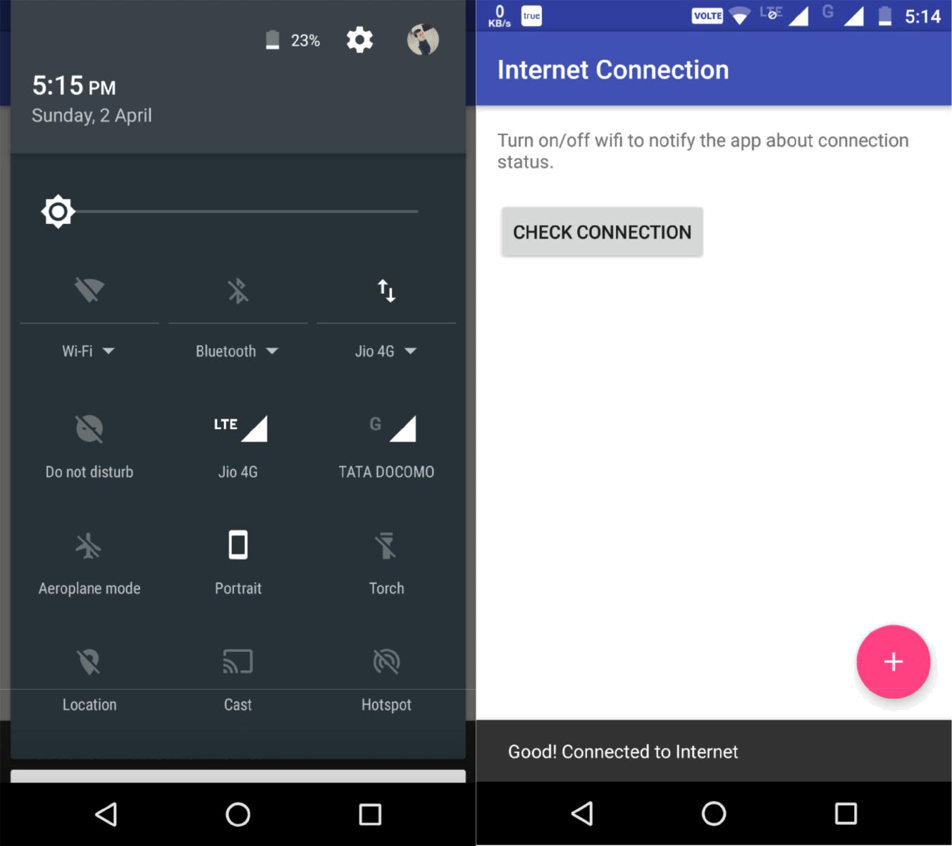

110


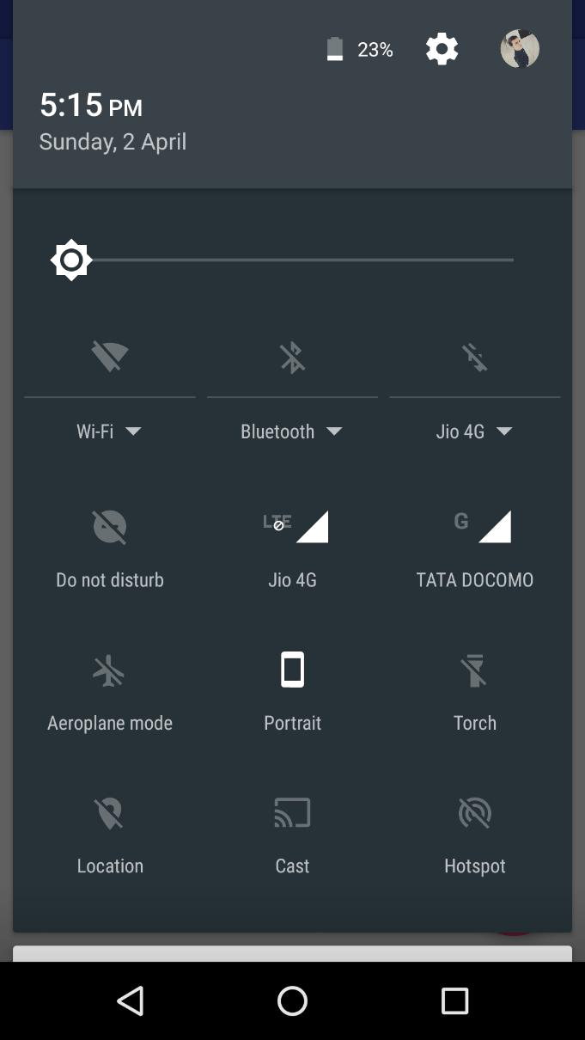

111

Practical:-11

AIM:- Create a notification app

MainActivity.java
package com.example.harsh.notification;

import android.app.Activity; import android.app.PendingIntent; import android.content.Context; import android.content.Intent;

import android.support.v4.app.NotificationCompat; import android.support.v7.app.AppCompatActivity; import android.os.Bundle; import android.view.View;

import android.widget.Button;
import android.app.NotificationManager;

public class MainActivity extends Activity { Button b1;

@Override

protected void onCreate(Bundle savedInstanceState) { super.onCreate(savedInstanceState); setContentView(R.layout.activity_main);

b1 = (Button)findViewById(R.id.button);

b1.setOnClickListener(new View.OnClickListener() { @Override

public void onClick(View v) {

addNotification();
}

});
}

private void addNotification() { NotificationCompat.Builder builder =
new NotificationCompat.Builder(this)

.setSmallIcon(R.drawable.notification_action_background)
.setContentTitle("Notifications
Example")
.setContentText("This is a test

notification");

Intent notificationIntent = new Intent(this, MainActivity.class);

PendingIntent contentIntent =
PendingIntent.getActivity(this, 0, notificationIntent ,

PendingIntent.FLAG_UPDATE_CURRENT); builder.setContentIntent(contentIntent);

112

NotificationManager manager = (NotificationManager) getSystemService(Context.NOTIFICATION_SERVICE);

manager.notify(0, builder.build());
}
}

activity_main.xml
<RelativeLayout

xmlns:android="http://schemas.android.com/apk/res/android" xmlns:tools="http://schemas.android.com/tools" android:layout_width="match_parent" android:layout_height="match_parent" android:layout_gravity="center" tools:context="MainActivity">

<TextView
android:id="@+id/textView1"

android:layout_width="wrap_content"
android:layout_height="wrap_content"
android:text="Practical 15"
android:textColor="#AB8E8E"

android:layout_alignParentTop="true"
android:layout_centerHorizontal="true"
android:textSize="20dp" />

<TextView
android:id="@+id/textView2"
android:layout_width="wrap_content"

android:layout_height="wrap_content"
android:text="Notification"
android:textColor="#3398CE"

android:textSize="18sp"
android:layout_below="@+id/textView1"
android:layout_centerHorizontal="true"
android:layout_marginTop="20dp" />

<Button
android:layout_width="wrap_content"

android:layout_height="wrap_content"
android:text="Get Notification"
android:id="@+id/button"
android:layout_marginTop="200dp"

android:layout_below="@+id/textView2"
android:layout_centerHorizontal="true" />

<TextView
android:text="click here "
android:layout_width="wrap_content"
android:layout_height="wrap_content"

android:layout_alignBottom="@+id/button"

113

android:layout_centerHorizontal="true" android:layout_marginBottom="40dp" android:id="@+id/textView3" />
</RelativeLayout>

AndroidManifest.xml

<?xml version="1.0" encoding="utf-8"?> <manifest

xmlns:android="http://schemas.android.com/apk/res/android" package="com.example.harsh.notification">

<application
android:allowBackup="true"
android:icon="@mipmap/ic_launcher"

android:label="@string/app_name"

android:roundIcon="@mipmap/ic_launcher_round" android:supportsRtl="true" android:theme="@style/AppTheme">
<activity android:name=".MainActivity">
<intent-filter>
<action

android:name="android.intent.action.MAIN" />

<category
android:name="android.intent.category.LAUNCHER" />

</intent-filter>
</activity>
</application>

</manifest>

114

Output:

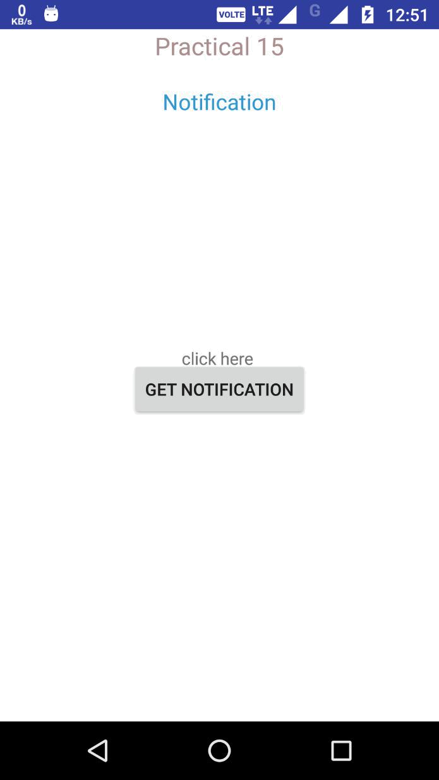

115


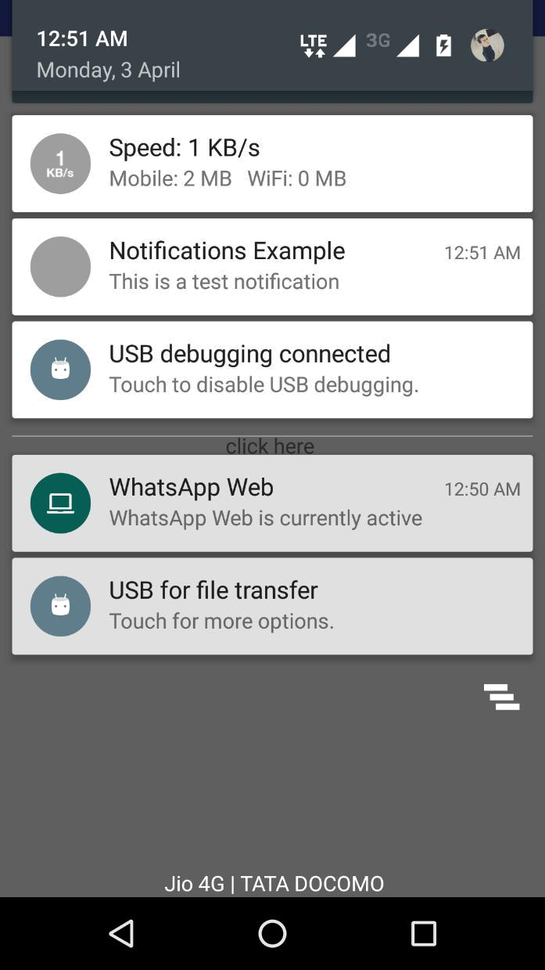

116

Practical:-12

AIM: Implement an Alarm Manager.

MainActivity.java
package com.example.harsh.alarmmanager;

import android.support.v7.app.AppCompatActivity; import android.os.Bundle;

import android.app.Activity; import android.app.AlarmManager; import android.app.PendingIntent; import android.content.Intent; import android.os.Bundle; import android.view.View;

import android.view.View.OnClickListener; import android.widget.Button; import android.widget.EditText;
import android.widget.Toast;

public class MainActivity extends Activity { Button b1;

@Override

protected void onCreate(Bundle savedInstanceState) { super.onCreate(savedInstanceState); setContentView(R.layout.activity_main); b1=(Button) findViewById(R.id.button1);

b1.setOnClickListener(new OnClickListener() {

@Override
public void onClick(View v) {

- TODO Auto-generated method stub startAlert();

}
});

} public void startAlert() {

EditText text = (EditText) findViewById(R.id.time); int i = Integer.parseInt(text.getText().toString()); Intent intent = new Intent(this,

MyBroadcastReceiver.class); PendingIntent pendingIntent =
PendingIntent.getBroadcast(

this.getApplicationContext(), 234324243,

intent, 0);
AlarmManager alarmManager = (AlarmManager)
getSystemService(ALARM_SERVICE);

alarmManager.set(AlarmManager.RTC_WAKEUP,

117

System.currentTimeMillis()
+ (i * 1000), pendingIntent);
Toast.makeText(this, "Alarm set in " + i + "
seconds",Toast.LENGTH_LONG).show();
}

}

MyBroadcastReceiver.java
package com.example.harsh.alarmmanager;

import android.content.BroadcastReceiver; import android.content.Context;

import android.content.Intent; import android.media.MediaPlayer; import android.widget.Toast;

public class MyBroadcastReceiver extends BroadcastReceiver { @Override

public void onReceive(Context context, Intent intent) {

Toast.makeText(context, "Alarm", Toast.LENGTH_LONG).show();

}
}

activity_main.xml
<?xml version="1.0" encoding="utf-8"?>
<RelativeLayout
xmlns:android="http://schemas.android.com/apk/res/android"

xmlns:tools="http://schemas.android.com/tools" android:layout_width="match_parent" android:layout_height="match_parent" tools:context=".MainActivity" >

<TextView
android:text="AlramManager"

android:layout_width="wrap_content"
android:layout_height="wrap_content"
android:layout_alignParentTop="true"

android:textColor="#F26544"
android:layout_centerHorizontal="true"
android:layout_marginTop="16dp"

android:id="@+id/textView" />

<EditText
android:id="@+id/time"

android:layout_width="wrap_content"
android:layout_height="wrap_content"
android:ems="10"

android:hint="

Number of seconds"

118

android:textColor="#F26544" android:inputType="numberDecimal" android:layout_alignParentTop="true" android:layout_centerHorizontal="true" android:layout_marginTop="51dp" />

<Button
android:id="@+id/button1"
android:layout_width="wrap_content"

android:layout_height="wrap_content"
android:text="Start"
android:layout_marginRight="144dp"
android:layout_alignParentBottom="true"

android:layout_centerHorizontal="true"
android:layout_marginBottom="158dp" />

</RelativeLayout>

AndroidManifest.xml

<?xml version="1.0" encoding="utf-8"?> <manifest

xmlns:android="http://schemas.android.com/apk/res/android" package="com.example.harsh.alarmmanager">
<uses-sdk
android:minSdkVersion="8"

android:targetSdkVersion="16" />

<uses-permission android:name="android.permission.VIBRATE"

/>

<application
android:allowBackup="true"

android:icon="@mipmap/ic_launcher"
android:label="@string/app_name"
android:theme="@style/AppTheme" >
<activity android:name=".MainActivity"

android:label="@string/app_name" >
<intent-filter>
<action

android:name="android.intent.action.MAIN" />

<category
android:name="android.intent.category.LAUNCHER" />

</intent-filter>
</activity>

<receiver android:name="MyBroadcastReceiver" > </receiver>
</application>

</manifest>

119

Output:

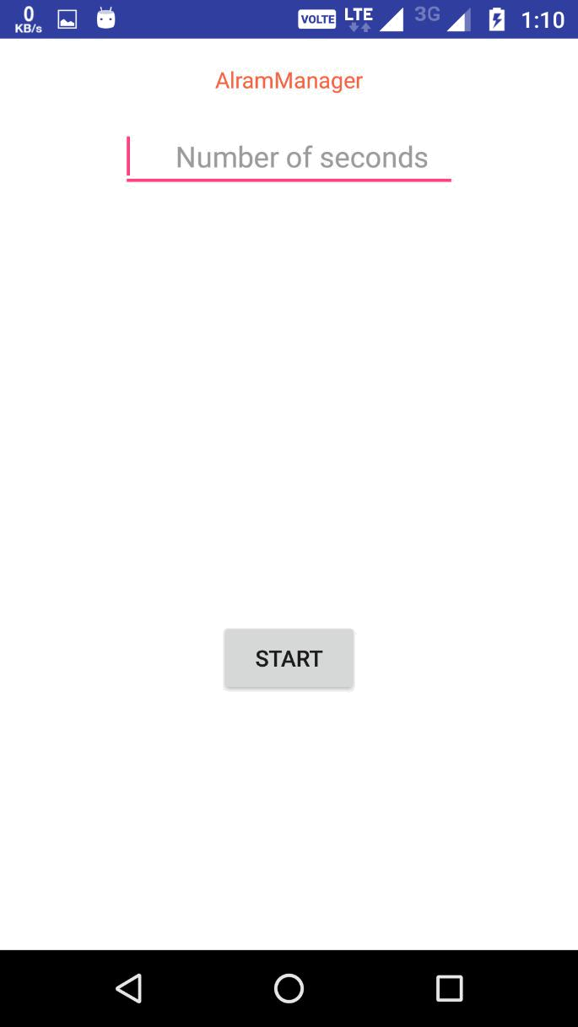

120


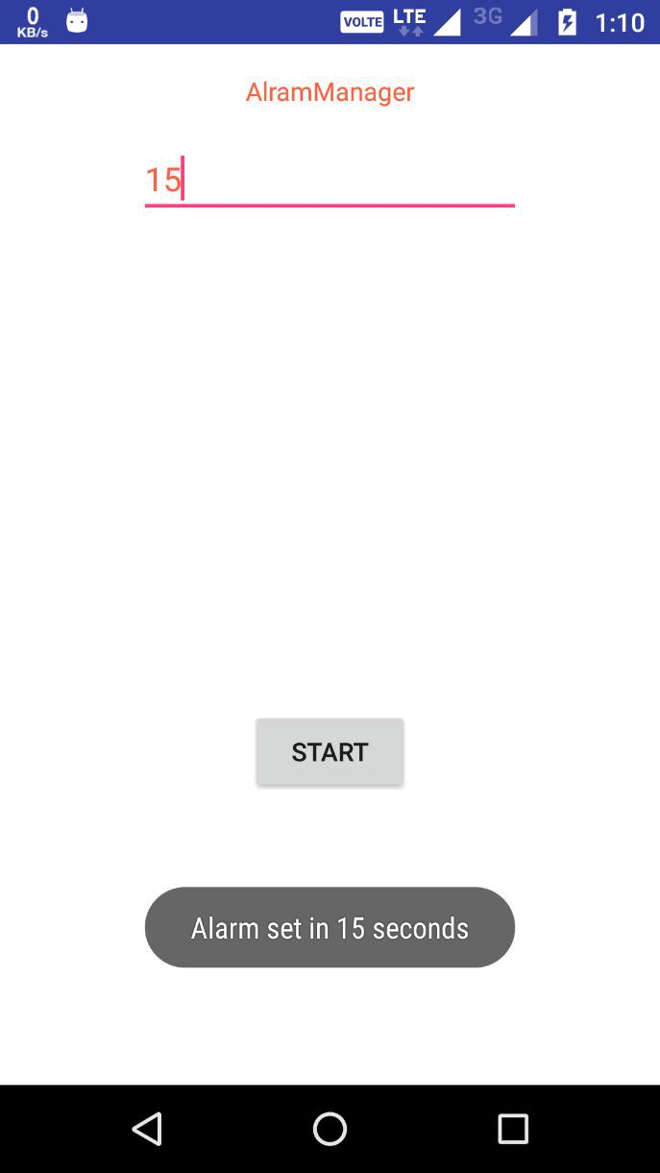

121

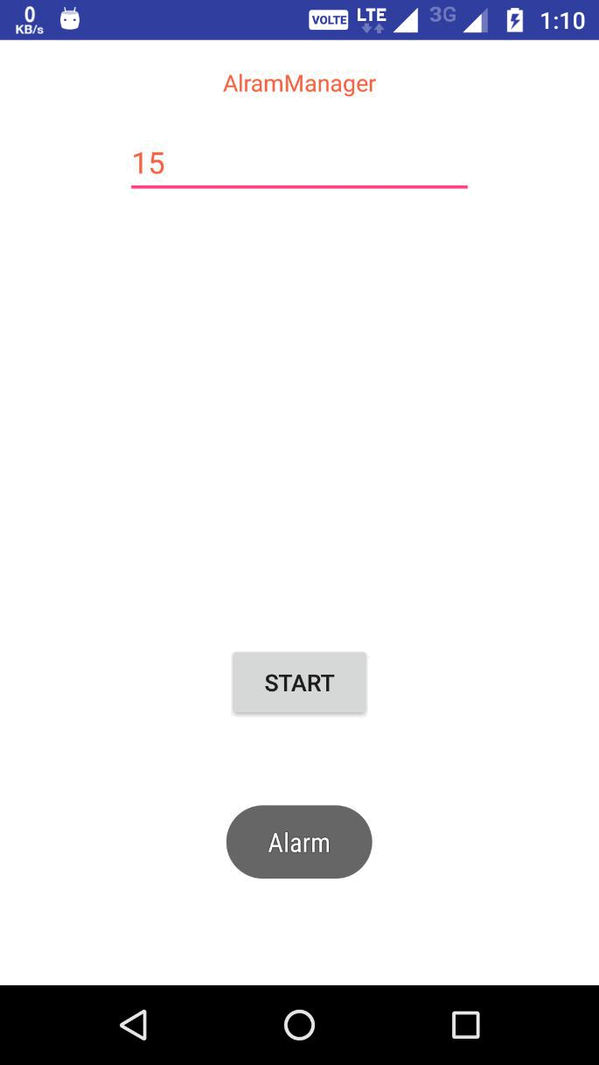

122

Practical:-13

AIM: Use Job Scheduler to do background updates.

MainActivity.java
package com.example.harsh.jobschedular;

import android.app.job.JobInfo; import android.app.job.JobScheduler; import android.content.ComponentName; import android.content.Context;

import android.support.v7.app.AppCompatActivity; import android.os.Bundle; import android.view.View;

import android.widget.Button;

public class MainActivity extends AppCompatActivity {

private JobScheduler mJobScheduler; private Button mScheduleJobButton; private Button mCancelAllJobsButton;

@Override

protected void onCreate(Bundle savedInstanceState) { super.onCreate(savedInstanceState); setContentView(R.layout.activity_main);

mJobScheduler = (JobScheduler) getSystemService(Context.JOB_SCHEDULER_SERVICE);
mScheduleJobButton = (Button)
findViewById(R.id.schedule_job);

mCancelAllJobsButton = (Button)
findViewById(R.id.cancel_all);

mScheduleJobButton.setOnClickListener(new

View.OnClickListener() {
@Override

public void onClick(View view) { JobInfo.Builder builder = new

JobInfo.Builder(1, new ComponentName(getPackageName(), SchedularService.class.getName()));

builder.setPeriodic(3000);
if (mJobScheduler.schedule(builder.build()) <=

0) {

//If something goes wrong
}

}

});

123

mCancelAllJobsButton.setOnClickListener(new View.OnClickListener() {
@Override
public void onClick(View v) {
mJobScheduler.cancelAll();

}
});

}

}

SchedularService.java
package com.example.harsh.jobschedular;

import android.app.job.JobParameters; import android.app.job.JobScheduler; import android.app.job.JobService; import android.os.Handler; import android.os.Message;
import android.widget.Toast;

/**
- Created by Intel on 4/1/2017.

*/
public class SchedularService extends JobService{

private Handler mJobHandler = new Handler( new Handler.Callback() {

@Override

public boolean handleMessage( Message msg ) { Toast.makeText( getApplicationContext(),

"JobService task running", Toast.LENGTH_SHORT ).show(); jobFinished( (JobParameters) msg.obj, false ); return true;

}
} );

@Override

public boolean onStartJob(JobParameters params ) { mJobHandler.sendMessage( Message.obtain( mJobHandler,
1, params ) );
return true;

}

@Override

public boolean onStopJob( JobParameters params ) { mJobHandler.removeMessages( 1 );
return false;

124

}

}

activity_main.xml

<?xml version="1.0" encoding="utf-8"?>

<LinearLayout
xmlns:android="http://schemas.android.com/apk/res/android"

android:layout_width="match_parent" android:layout_height="match_parent" android:orientation="vertical" android:paddingTop="160dp">

<Button

android:id="@+id/schedule_job"

android:layout_width="166dp"
android:layout_height="wrap_content"
android:text="Schedule Job"
android:layout_gravity="center_horizontal"

android:textSize="40px"/>

<Button

android:id="@+id/cancel_all"
android:layout_width="166dp"
android:layout_height="wrap_content"
android:text="Cancel All"

android:layout_gravity="center_horizontal"
android:textSize="40px"
/>

</LinearLayout>

AndroidManifest.xml

<?xml version="1.0" encoding="utf-8"?> <manifest

xmlns:android="http://schemas.android.com/apk/res/android" package="com.example.harsh.jobschedular">

<application
android:allowBackup="true"
android:icon="@mipmap/ic_launcher"

android:label="@string/app_name"
android:supportsRtl="true"
android:theme="@style/AppTheme">

<activity android:name=".MainActivity">

125

<intent-filter>
<action

android:name="android.intent.action.MAIN" />

<category
android:name="android.intent.category.LAUNCHER" />

</intent-filter>
</activity>
<service android:name=".SchedularService"

android:permission="android.permission.BIND_JOB_SERVICE" /> </application>

</manifest>

126

Output:-

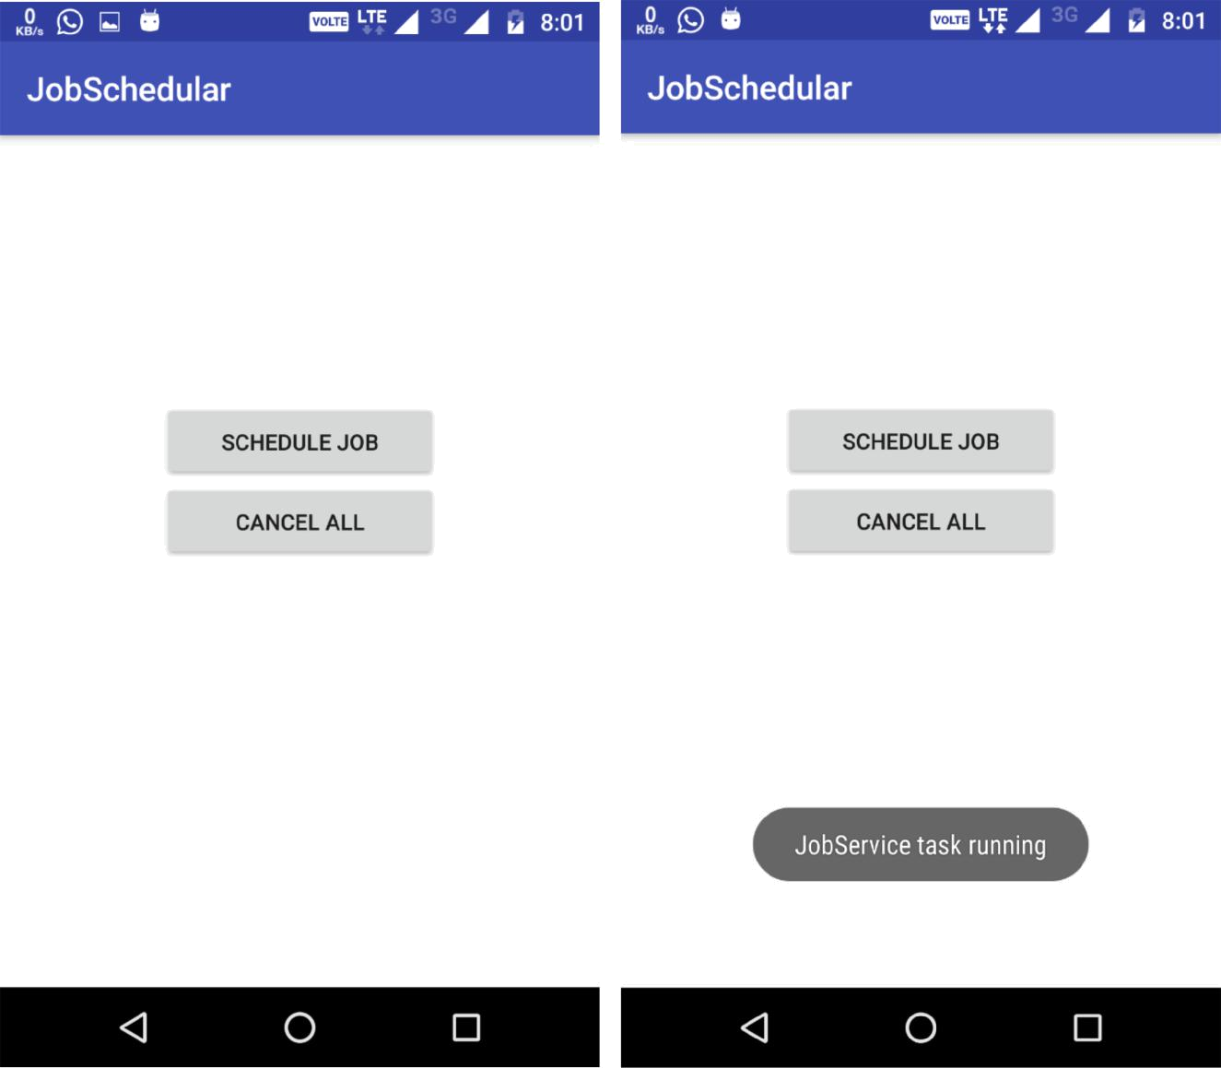

127

Practical:-14

AIM: Create an app that allows users to enter notes
- Save the notes in a SQLite database
- Create an app that stores data in an SQL database.
- Allow users to add, delete, and edit data items..

AndroidManifest.xml

<?xml version="1.0" encoding="utf-8"?> <manifest

xmlns:android="http://schemas.android.com/apk/res/android" package="com.example.harsh.contentresolver">

<application

android:allowBackup="true"
android:icon="@mipmap/ic_launcher"
android:label="@string/app_name"

android:roundIcon="@mipmap/ic_launcher_round" android:supportsRtl="true" android:theme="@style/AppTheme">
<activity android:name=".MainActivity">

<intent-filter>
<action
android:name="android.intent.action.MAIN" />

<category
android:name="android.intent.category.LAUNCHER" />
</intent-filter>

</activity>
</application>

</manifest>

DatabaseHelper.java

package com.example.harsh.contentresolver;

import java.util.ArrayList;
import java.util.List;

import android.content.ContentValues; import android.content.Context; import android.database.Cursor;

import android.database.sqlite.SQLiteDatabase; import android.database.sqlite.SQLiteOpenHelper;

public class DatabaseHelper extends SQLiteOpenHelper {

- All Static variables
- Database Version

128

private static final int DATABASE_VERSION = 1;

// Database Name

private static final String DATABASE_NAME = "contactsManager";

// Contacts table name
private static final String TABLE_CONTACTS = "contacts";

// Contacts Table Columns names

public static final String KEY_ID = "id"; public static final String KEY_NAME = "name";
public static final String KEY_PH_NO = "phone_number";

public DatabaseHelper(Context context) {
super(context, DATABASE_NAME, null, DATABASE_VERSION);

}

- Creating Tables @Override

public void onCreate(SQLiteDatabase db) {
String CREATE_CONTACTS_TABLE = "CREATE TABLE " +
TABLE_CONTACTS + "("
+ KEY_ID + " INTEGER PRIMARY KEY," + KEY_NAME

- " TEXT,"

- KEY_PH_NO + " TEXT" + ")"; db.execSQL(CREATE_CONTACTS_TABLE);

}

- Upgrading database @Override

public void onUpgrade(SQLiteDatabase db, int oldVersion,
int newVersion) {
// Drop older table if existed
db.execSQL("DROP TABLE IF EXISTS " + TABLE_CONTACTS);

- Create tables again onCreate(db);

}

/**

- All CRUD(Create, Read, Update, Delete) Operations
*/

// Adding new contact

void addContact(Contact contact) {
SQLiteDatabase db = this.getWritableDatabase();

ContentValues values = new ContentValues(); values.put(KEY_NAME, contact.getName()); // Contact
Name
values.put(KEY_PH_NO, contact.getPhoneNumber()); //

129

Contact Phone

// Inserting Row

db.insert(TABLE_CONTACTS, null, values); db.close(); // Closing database connection
}

- Getting single contact
Contact getContact(int id) {

SQLiteDatabase db = this.getReadableDatabase();

Cursor cursor = db.query(TABLE_CONTACTS, new String[]
{ KEY_ID,

KEY_NAME, KEY_PH_NO }, KEY_ID + "=?", new String[] { String.valueOf(id) }, null,
null, null, null);

if (cursor != null)

cursor.moveToFirst();

Contact contact = new

Contact(Integer.parseInt(cursor.getString(0)),
cursor.getString(1), cursor.getString(2));

- return contact return contact;

}

// Getting All Contacts

public Cursor getAllContacts() { // Select All Query
String selectQuery = "SELECT * FROM " +
TABLE_CONTACTS;

SQLiteDatabase db = this.getWritableDatabase(); Cursor cursor = db.rawQuery(selectQuery, null);

return cursor;

// looping through all rows and adding to list

}

// Updating single contact

public int updateContact(String name,String contact) { SQLiteDatabase db = this.getWritableDatabase();

ContentValues values = new ContentValues(); values.put(KEY_NAME,name); values.put(KEY_PH_NO,contact);

// updating row

return db.update(TABLE_CONTACTS,values,null,null);

}

130

- Deleting single contact
public void deleteContact() {

SQLiteDatabase db = this.getWritableDatabase(); ContentValues values = new ContentValues();

- values.put(KEY_NAME,name); db.delete(TABLE_CONTACTS,null,null);

db.close();
}

- Getting contacts Count public int getContactsCount() {

String countQuery = "SELECT * FROM " +
TABLE_CONTACTS;

SQLiteDatabase db = this.getReadableDatabase(); Cursor cursor = db.rawQuery(countQuery, null); cursor.close();

// return count

return cursor.getCount();

}

}

MainActivity.java

package com.example.harsh.contentresolver;

import android.database.Cursor;
import android.os.Bundle;

import android.support.v7.app.AppCompatActivity; import android.util.Log; import android.view.View;

import android.widget.ArrayAdapter; import android.widget.Button; import android.widget.EditText; import android.widget.ListView; import android.widget.Toast;

import java.util.ArrayList;
import java.util.List;

public class MainActivity extends AppCompatActivity {

private Cursor cursor;
Button add,delete,update,show;

EditText e1,e2;
ListView listview,listview1;
@Override

131

protected void onCreate(Bundle savedInstanceState) { super.onCreate(savedInstanceState); setContentView(R.layout.activity_main);

add = (Button) findViewById(R.id.add); show = (Button) findViewById(R.id.show); update = (Button) findViewById(R.id.update); delete = (Button) findViewById(R.id.delete);

e1= (EditText) findViewById(R.id.e1);
e2= (EditText) findViewById(R.id.e2);

listview= (ListView) findViewById(R.id.listview); listview1= (ListView) findViewById(R.id.listview1);

/**
- CRUD Operations

- */
// Inserting Contacts

add.setOnClickListener(new View.OnClickListener() { @Override

public void onClick(View v) {
DatabaseHelper db = new
DatabaseHelper(MainActivity.this);
Log.d("Insert: ", "Inserting ..");

db.addContact(new
Contact(e1.getText().toString(),e2.getText().toString()));

// Reading all contacts
Log.d("Reading: ", "Reading all contacts..");

// Writing Contacts to log

Toast.makeText(MainActivity.this,"inserted",Toast.LENGTH_LONG) .show();

}

});

update.setOnClickListener(new View.OnClickListener() { @Override

public void onClick(View v) {

DatabaseHelper db = new DatabaseHelper(MainActivity.this);

db.updateContact(e1.getText().toString(),e2.getText().toString ());

132

Toast.makeText(MainActivity.this, " contact updated" , Toast.LENGTH_LONG).show();

}
});

delete.setOnClickListener(new View.OnClickListener() { @Override

public void onClick(View v) {

DatabaseHelper db = new

DatabaseHelper(MainActivity.this); db.deleteContact();

Toast.makeText(MainActivity.this, " contact deleted" , Toast.LENGTH_LONG).show();

}
});

show.setOnClickListener(new View.OnClickListener() { @Override

public void onClick(View v) {

DatabaseHelper db = new
DatabaseHelper(MainActivity.this);
cursor = db.getAllContacts();

List<String> strName= new ArrayList<String>(); List<String> strPhone= new
ArrayList<String>();
if (cursor.moveToFirst()) {

do {

strName.add(cursor.getString(cursor.getColumnIndex(DatabaseHel per.KEY_NAME)));
strPhone.add(

cursor.getString(cursor.getColumnIndex(DatabaseHelper.KEY_PH_N O)));

} while (cursor.moveToNext());

}

cursor.close();
ArrayAdapter<String> adapter = new

133

ArrayAdapter<String>(MainActivity.this,
R.layout.listview,R.id.t1,

strName);
ArrayAdapter<String> ada = new
ArrayAdapter<String>(MainActivity.this,R.layout.list,
R.id.t1,strPhone);

listview.setAdapter(adapter);

listview1.setAdapter(ada);

}
});
}

}

Contact.xml

package com.example.harsh.contentresolver;

/**
- Created by HARSH JOBANPUTRA on 4/3/2017.

*/

public class Contact {

int _id;
String _name;

String _phone_number;

- Empty constructor public Contact(){

}
// constructor

public Contact(int id, String name, String _phone_number){ this._id = id;
this._name = name;
this._phone_number = _phone_number;

}

// constructor

public Contact(String name, String _phone_number){ this._name = name;
this._phone_number = _phone_number;
}

- getting ID public int getID(){

return this._id;

}

- setting id

134

public void setID(int id){
this._id = id;

}

// getting name
public String getName(){

return this._name;

}

// setting name

public void setName(String name){ this._name = name;

}

// getting phone number
public String getPhoneNumber(){

return this._phone_number;

}

// setting phone number

public void setPhoneNumber(String phone_number){ this._phone_number = phone_number;

}
}

activity_main.xml

<?xml version="1.0" encoding="utf-8"?>

<LinearLayout
xmlns:android="http://schemas.android.com/apk/res/android"
xmlns:app="http://schemas.android.com/apk/res-auto"
xmlns:tools="http://schemas.android.com/tools"

android:layout_width="match_parent"
android:layout_height="match_parent"
android:orientation="vertical"

tools:context="com.example.harsh.contentresolver.MainActivity"

>

<EditText
android:layout_width="match_parent"

android:layout_height="wrap_content"
android:hint="Name"
android:id="@+id/e1"
/>
<EditText
android:layout_width="match_parent"
android:layout_height="wrap_content"

android:hint="Contact Number"
android:id="@+id/e2"
/>

135

<Button
android:layout_width="match_parent"
android:layout_height="wrap_content"
android:id="@+id/add"

android:text="Insert"

/>

<Button
android:layout_width="match_parent"
android:layout_height="wrap_content"

android:id="@+id/update"
android:text="Update"
/>

<Button
android:layout_width="match_parent"
android:layout_height="wrap_content"
android:id="@+id/delete"

android:text="Delete"

/>
<Button
android:layout_width="match_parent"

android:layout_height="wrap_content"
android:id="@+id/show"
android:text="Show"

/>

<LinearLayout
android:layout_width="wrap_content"

android:layout_height="wrap_content"
android:orientation="horizontal">
<ListView

android:layout_width="190dp"
android:layout_height="wrap_content"
android:textAlignment="center"
android:layout_marginTop="10dp"

android:id="@+id/listview">
</ListView>
<ListView

android:layout_width="190dp"
android:layout_height="wrap_content"
android:id="@+id/listview1"

android:layout_marginTop="10dp"

android:textAlignment="center"

></ListView>

</LinearLayout>

</LinearLayout>

136

listview.xml

<?xml version="1.0" encoding="utf-8"?> <LinearLayout

xmlns:android="http://schemas.android.com/apk/res/android"
android:orientation="vertical"

android:layout_width="match_parent" android:layout_height="match_parent"> <TextView

android:layout_width="wrap_content" android:layout_height="wrap_content" android:id="@+id/t1"/>

</LinearLayout>

list.xml

<?xml version="1.0" encoding="utf-8"?>

<LinearLayout
xmlns:android="http://schemas.android.com/apk/res/android"
android:orientation="vertical"

android:layout_width="match_parent"
android:layout_height="match_parent">

<TextView

android:layout_width="wrap_content"
android:layout_height="wrap_content"
android:id="@+id/t1"/>

</LinearLayout>

137

Output:
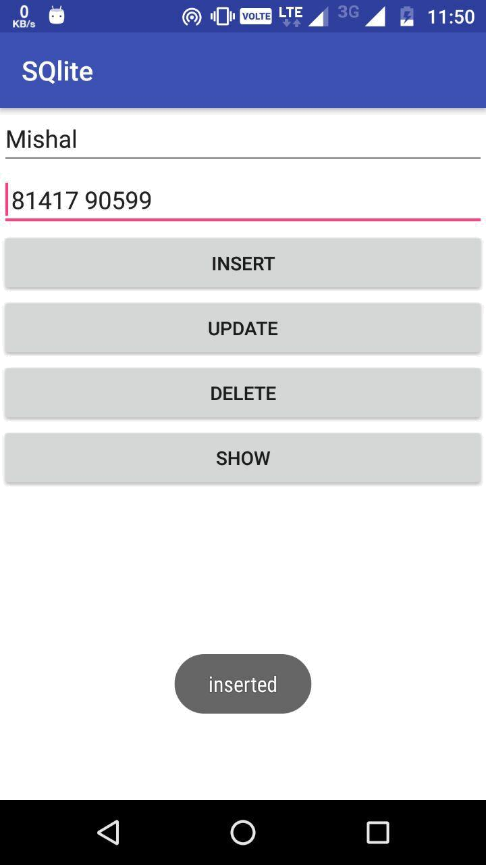

138


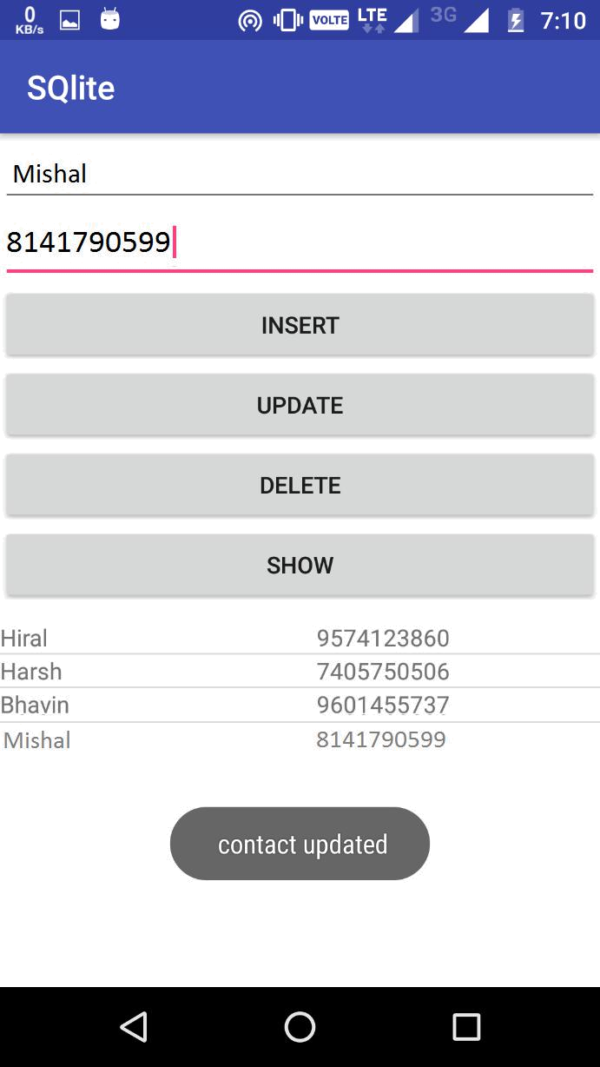

139


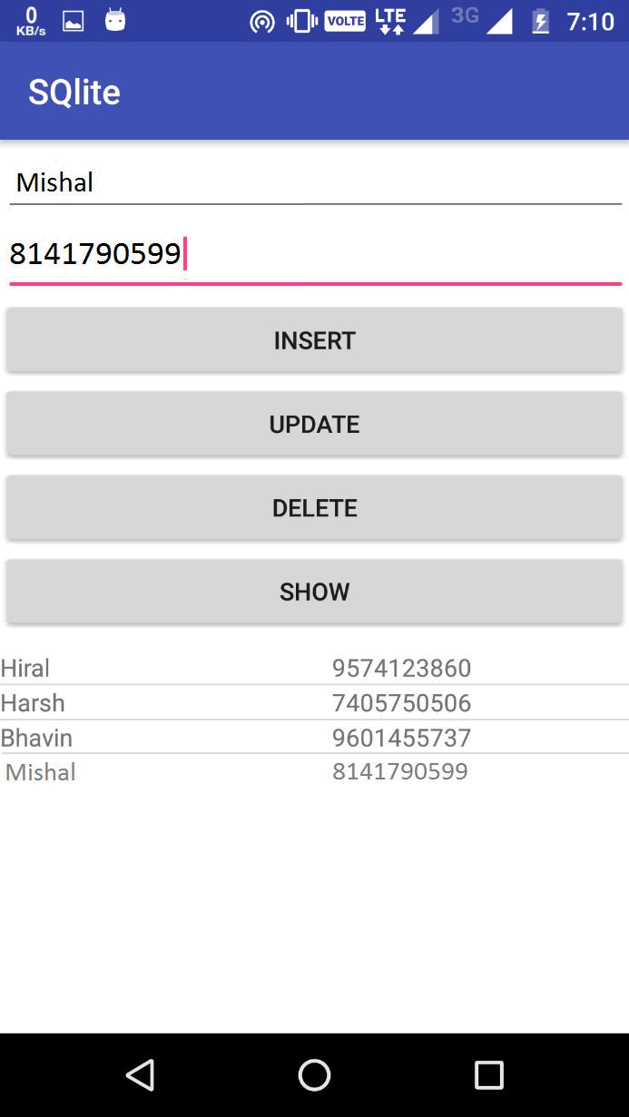

140

